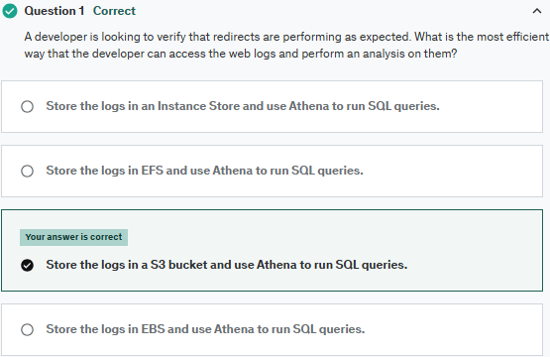

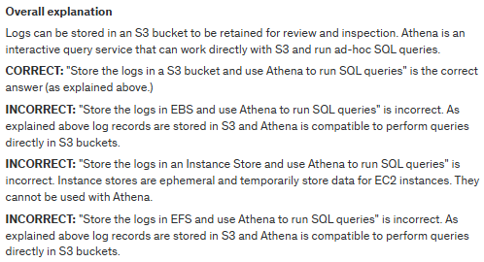

**References**:

<https://docs.aws.amazon.com/athena/latest/ug/what-is.html>

**Save time with our AWS cheat sheets:**

<https://digitalcloud.training/amazon-athena/>

**Domain**

AWS Analytics

Notes:

Amazon Athena is a query service to analyze data directly in Amazon Simple Storage (Amazon S3) using SQL.

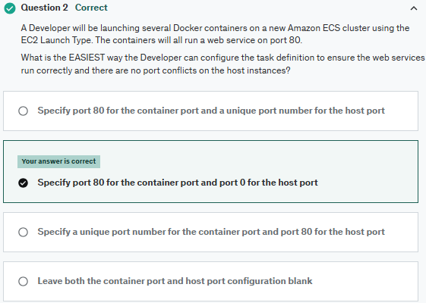

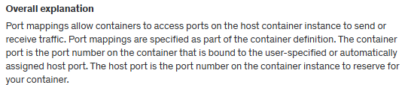



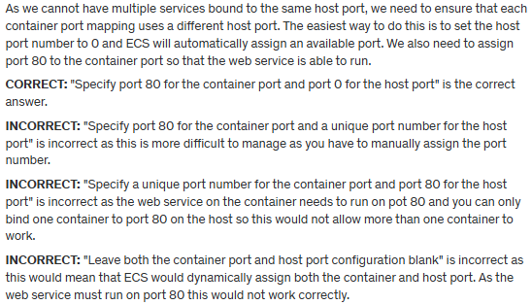

**References:**

<https://docs.aws.amazon.com/AmazonECS/latest/APIReference/API_PortMapping.html>

**Save time with our AWS cheat sheets:**

<https://digitalcloud.training/amazon-ecs-and-eks/>

**Domain**

AWS Compute

Notes:

Port mappings allow containers to access ports on the host container instance to send or receive traffic.

Amazon Elastic Container (ECS) is a container management service that supports Docker containers.

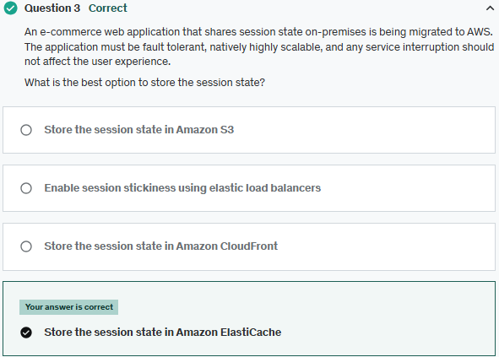

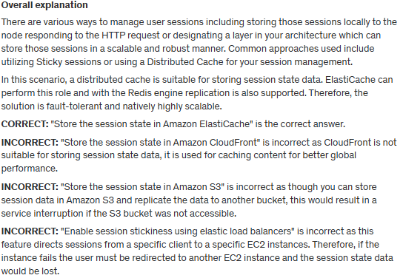

**References:**

<https://aws.amazon.com/caching/session-management/>

**Save time with our AWS cheat sheets:**

<https://digitalcloud.training/amazon-elasticache/>

**Domain**

AWS Database

Notes:

Amazon ElastiCache is a web service to deploy and run Memcached or Redis server nodes in the cloud.

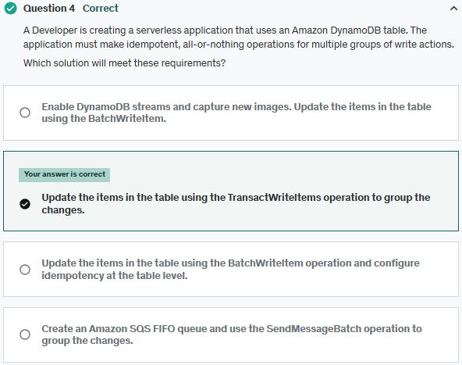

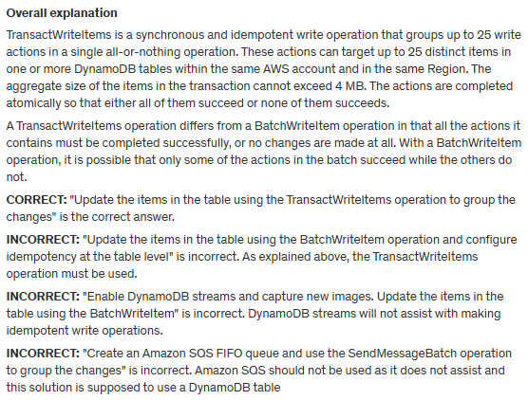

**References:**

<https://docs.aws.amazon.com/amazondynamodb/latest/APIReference/API_TransactWriteItems.html>

**Save time with our AWS cheat sheets:**

<https://digitalcloud.training/amazon-dynamodb/>

**Domain**

AWS Database

Notes:

Idempotent = performing it again (using the same inputs) does not change the result.

Amazon DynamoDB is NoSQL database service, data is synchronously replicated across 3 AZs in a region.

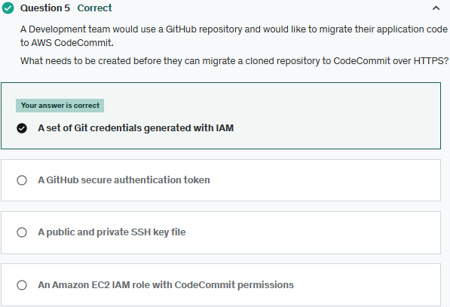

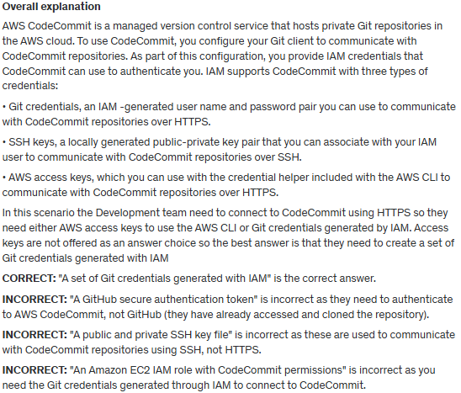

**References:**

<https://docs.aws.amazon.com/IAM/latest/UserGuide/id_credentials_ssh-keys.html>

**Save time with our AWS cheat sheets:**

<https://digitalcloud.training/aws-developer-tools/>

**Domain**

AWS Developer Tools

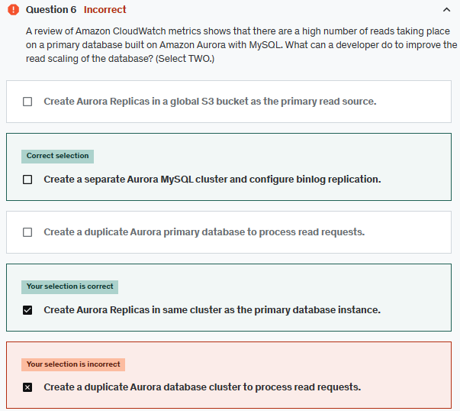

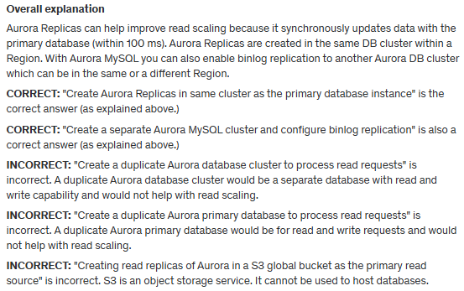

**References**:

<https://docs.aws.amazon.com/AmazonRDS/latest/AuroraUserGuide/Aurora.Managing.Performance.html#Aurora.Managing.Performance.ReadScaling>

**Save time with our AWS cheat sheets:**

<https://digitalcloud.training/amazon-aurora/>

**Domain**

AWS Management & Governance

Notes:

Amazon Aurora is a relational database service. Aurora replica (up to 15).

Binlog replication

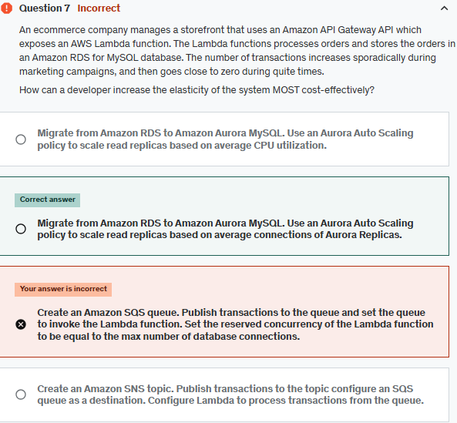

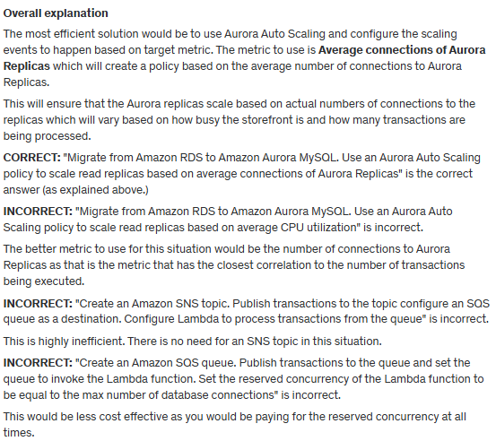

**References:**

<https://docs.aws.amazon.com/AmazonRDS/latest/AuroraUserGuide/Aurora.Integrating.AutoScaling.html>

**Save time with our AWS cheat sheets:**

<https://digitalcloud.training/amazon-aurora/>

**Domain**

AWS Database

Notes:

Amazon Aurora Auto Scaling with Aurora Replicas (reader DB instances), for MySQL and PostgreSQL.

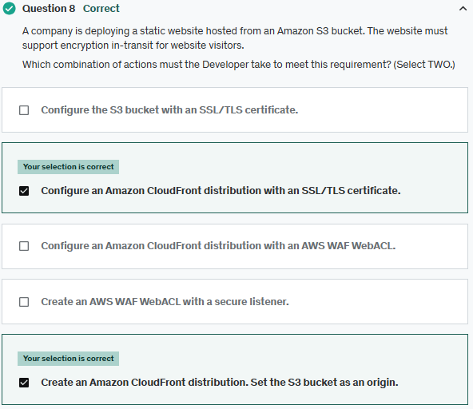

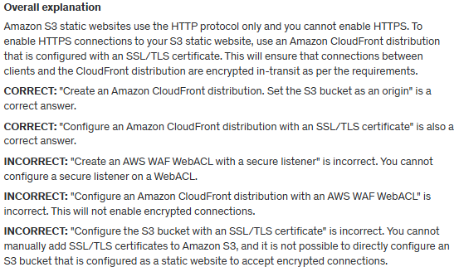

**References:**

<https://aws.amazon.com/premiumsupport/knowledge-center/cloudfront-serve-static-website/>

**Save time with our AWS cheat sheets:**

<https://digitalcloud.training/amazon-cloudfront/>

**Domain**

AWS Networking & Content Delivery

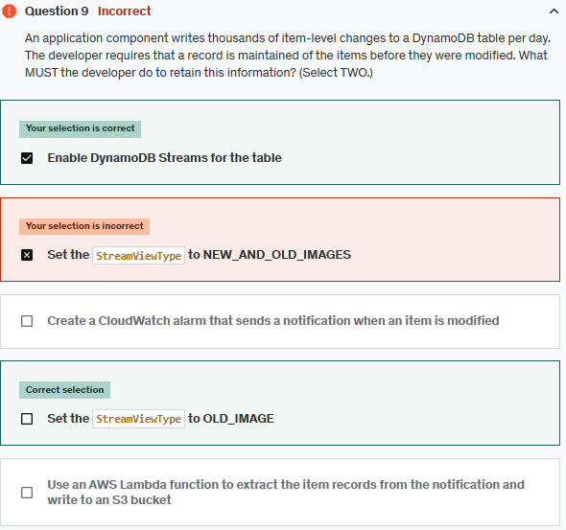

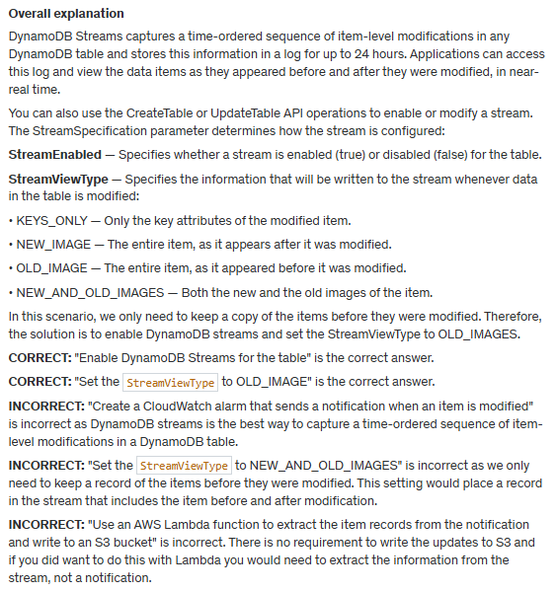

**References:**

<https://docs.aws.amazon.com/amazondynamodb/latest/developerguide/Streams.html>

**Save time with our AWS cheat sheets:**

[https://digitalcloud.training/amazon-dynamodb/](https://digitalcloud.training/certification-training/aws-developer-associate/aws-database/amazon-dynamodb/)

**Domain**

AWS Database

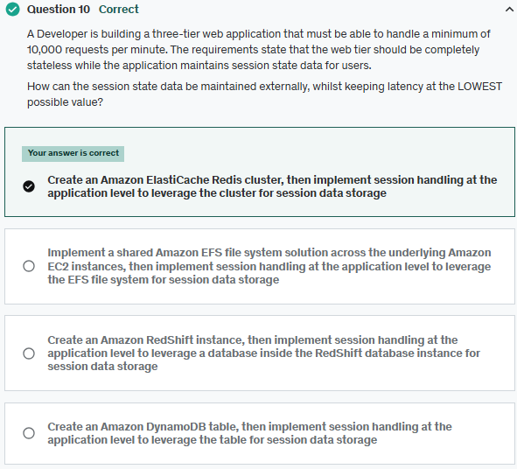

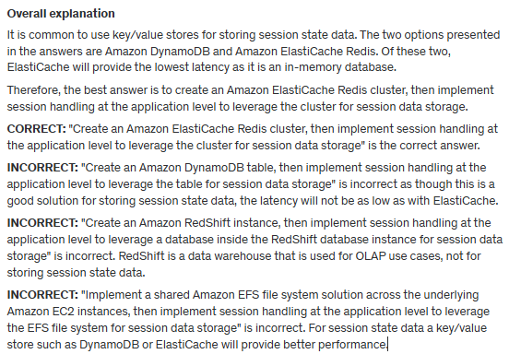

**References:**

<https://aws.amazon.com/caching/session-management/>

**Save time with our AWS cheat sheets:**

<https://digitalcloud.training/amazon-elasticache/>

**Domain**

AWS Database

Notes:

Stateless vs. Stateful:

Stateless: No memory of past interactions. Ex.: Sending a GET request to an API, HTTP Protocol, REST APIs, Cloud computing (AWS Lambda, Google Cloud Functions).

Stateful: Retains memory of past interactions. Ex. Online banking systems where your login session persists across multiple actions.

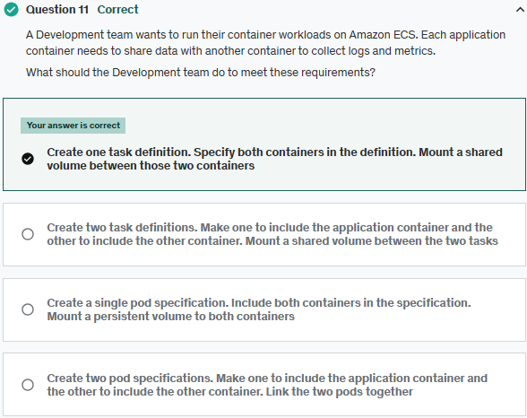

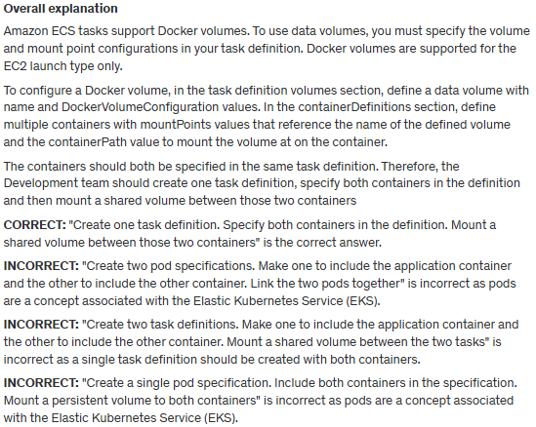

**References:**

<https://docs.aws.amazon.com/AmazonECS/latest/developerguide/docker-volumes.html>

**Save time with our AWS cheat sheets:**

<https://digitalcloud.training/amazon-ecs-and-eks/>

**Domain**

AWS Compute

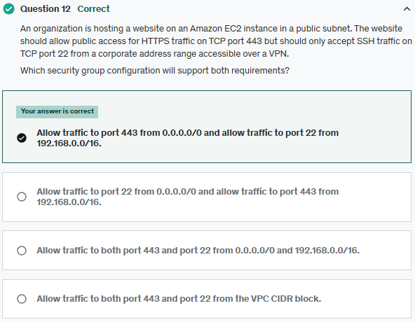

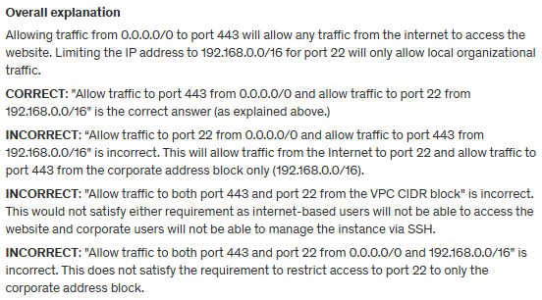

**References**:

<https://docs.aws.amazon.com/vpc/latest/userguide/VPC_SecurityGroups.html>

**Save time with our AWS cheat sheets:**

<https://digitalcloud.training/amazon-ec2/>

**Domain**

AWS Networking & Content Delivery

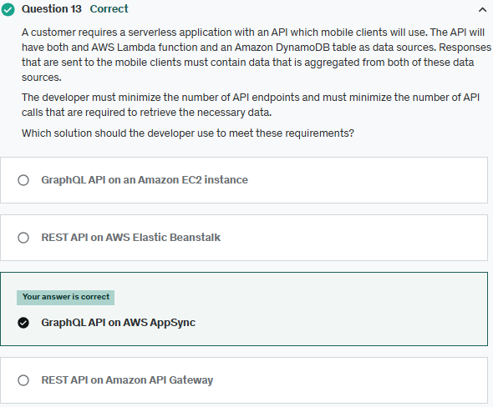

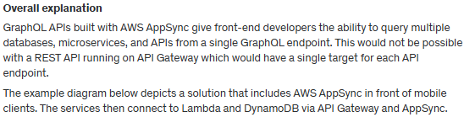

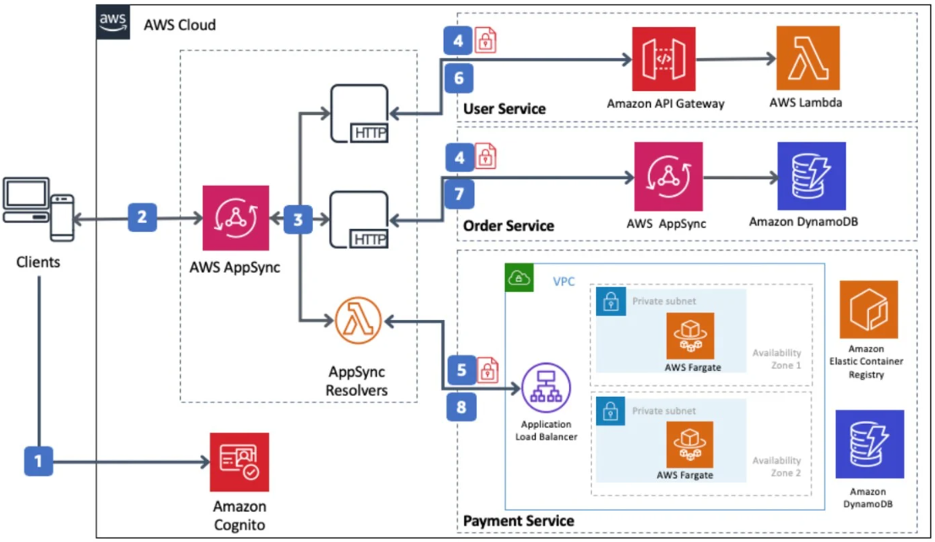

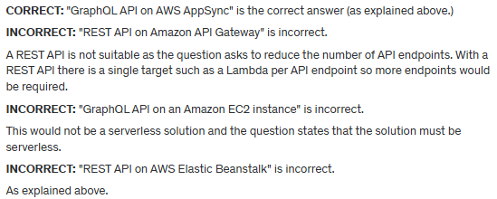

**References:**

<https://aws.amazon.com/blogs/mobile/appsync-microservices/>

**Domain**

AWS Networking & Content Delivery

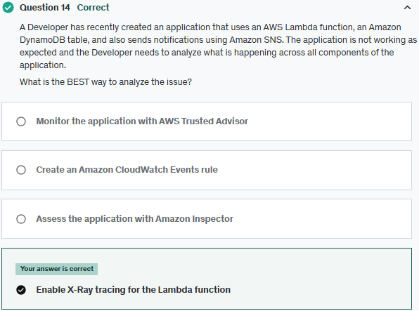

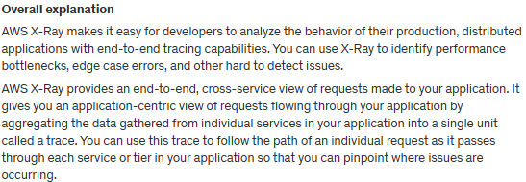

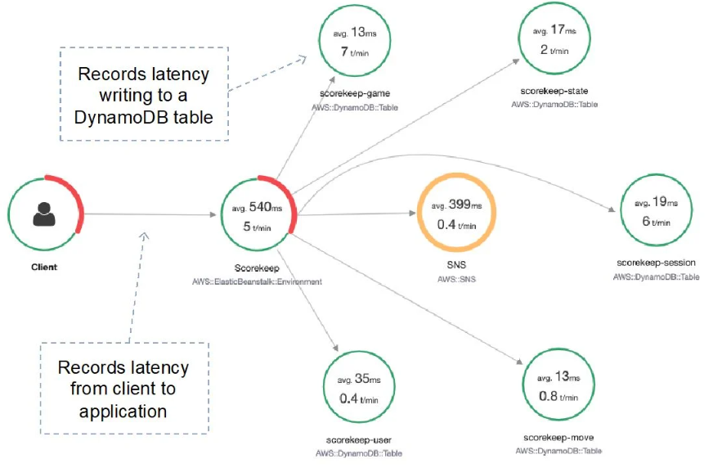

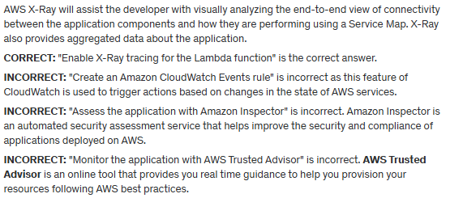

**References:**

<https://aws.amazon.com/xray/features/>

**Save time with our AWS cheat sheets:**

<https://digitalcloud.training/aws-developer-tools/>

**Domain**

AWS Developer Tools

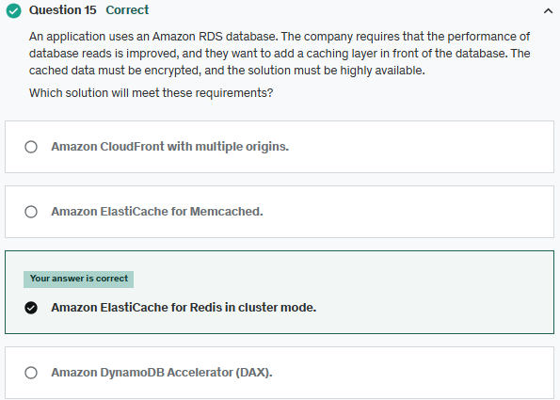

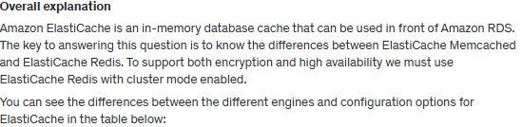

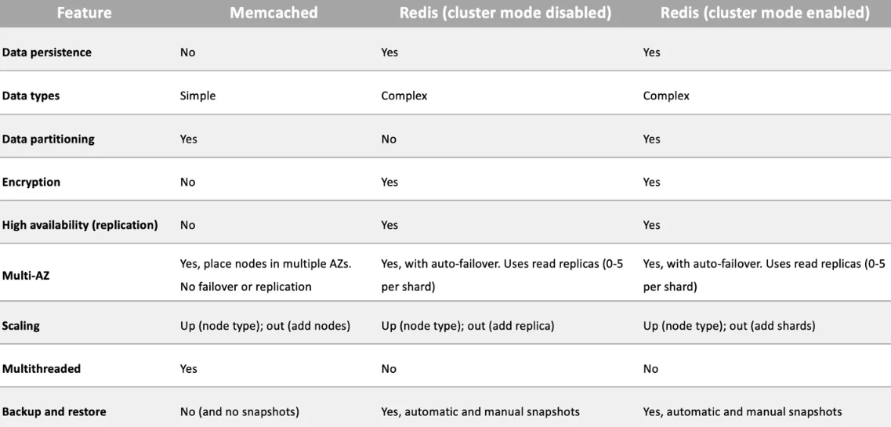

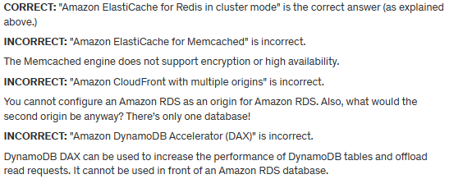

**References:**

<https://docs.aws.amazon.com/AmazonElastiCache/latest/red-ug/Replication.Redis-RedisCluster.html>

**Save time with our AWS cheat sheets:**

<https://digitalcloud.training/amazon-elasticache/>

**Domain**

AWS Database

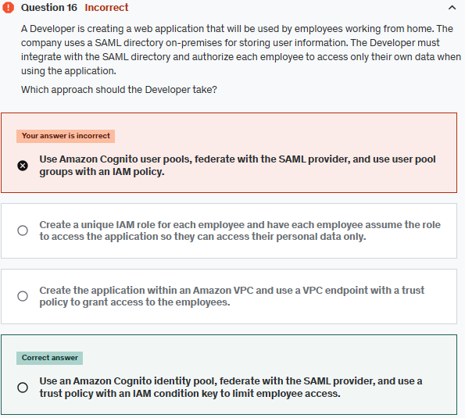

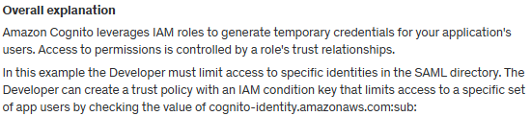

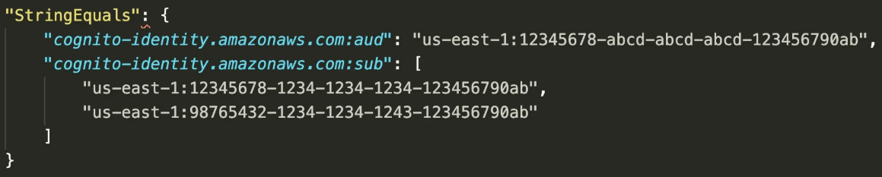

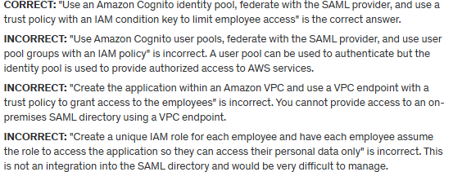

**References:**

[https://docs.aws.amazon.com/cognito/latest/Developerguide/role-trust-and-permissions.html](https://docs.aws.amazon.com/cognito/latest/developerguide/role-trust-and-permissions.html)

[https://docs.aws.amazon.com/cognito/latest/Developerguide/iam-roles.html](https://docs.aws.amazon.com/cognito/latest/developerguide/iam-roles.html)

**Save time with our AWS cheat sheets:**

<https://digitalcloud.training/amazon-cognito/>

**Domain**

AWS Security, Identity, & Compliance

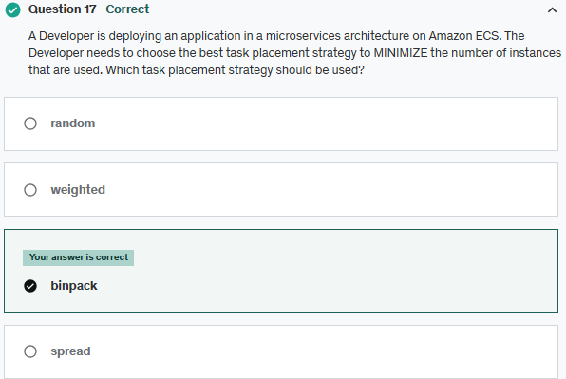

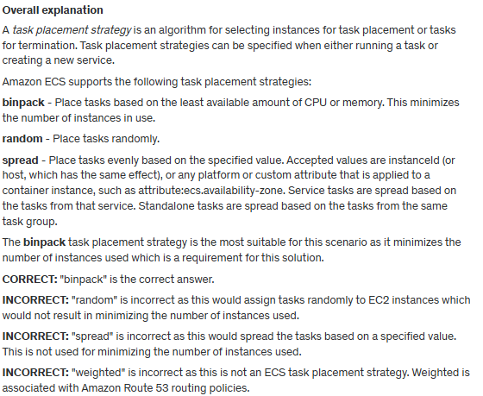

**References:**

<https://docs.aws.amazon.com/AmazonECS/latest/developerguide/task-placement-strategies.html>

**Save time with our AWS cheat sheets:**

<https://digitalcloud.training/amazon-ecs-and-eks/>

**Domain**

AWS Compute

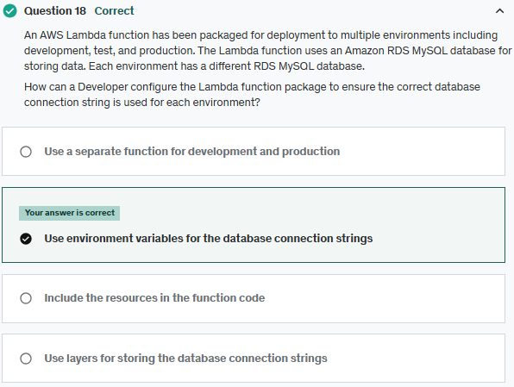

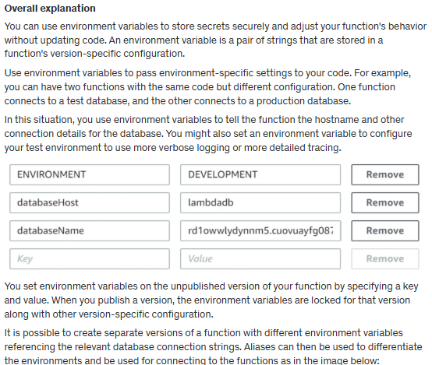

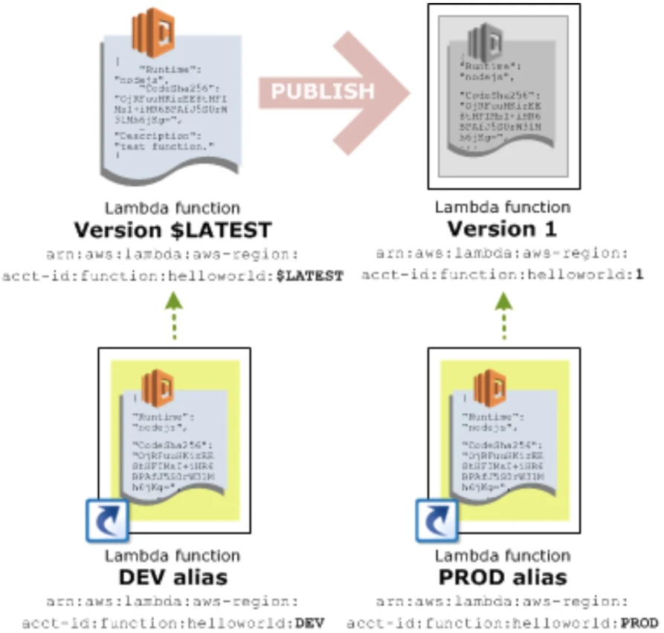

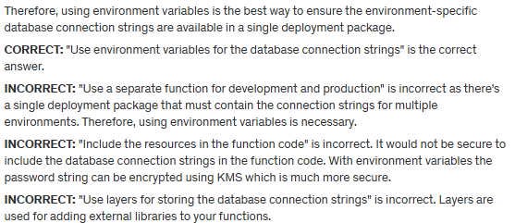

**References:**

<https://docs.aws.amazon.com/lambda/latest/dg/configuration-envvars.html>

**Domain**

AWS Compute

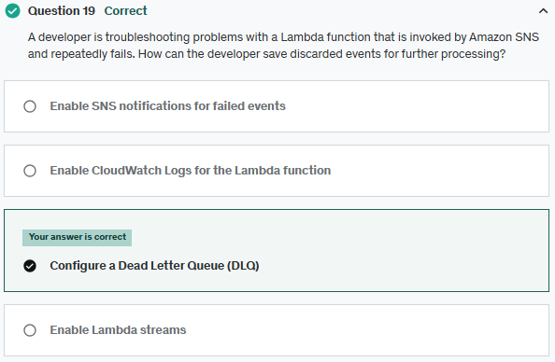

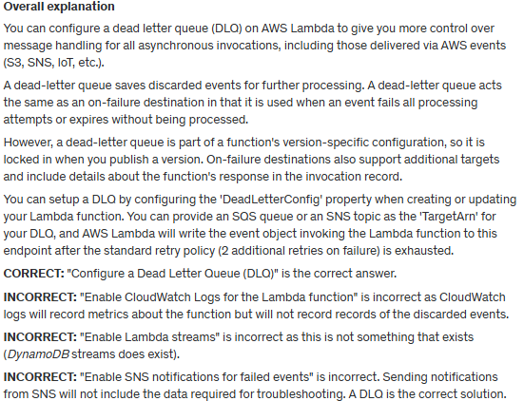

**References:**

[https://digitalcloud.training/aws-lambda/](https://digitalcloud.training/certification-training/aws-developer-associate/aws-compute/aws-lambda/)

**Save time with our AWS cheat sheets:**

<https://docs.aws.amazon.com/lambda/latest/dg/invocation-async.html>

**Domain**

AWS Application Integration

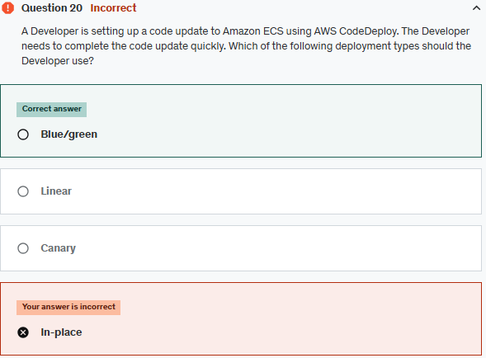

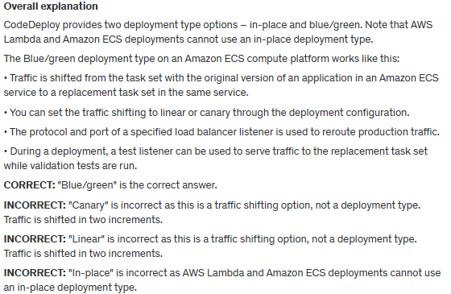

**References:**

<https://docs.aws.amazon.com/codedeploy/latest/userguide/deployments.html>

**Save time with our AWS cheat sheets:**

<https://digitalcloud.training/aws-developer-tools/>

**Domain**

AWS Compute

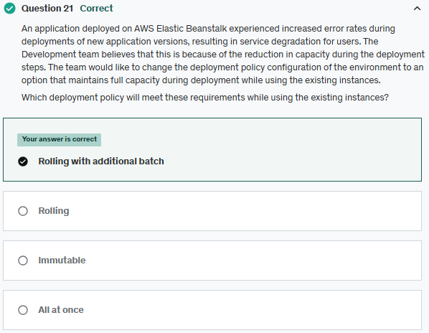

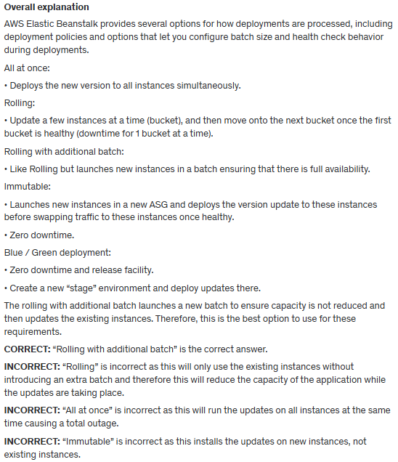

**References:**

<https://docs.aws.amazon.com/elasticbeanstalk/latest/dg/using-features.rolling-version-deploy.html>

**Save time with our AWS cheat sheets:**

<https://digitalcloud.training/aws-elastic-beanstalk/>

**Domain**

AWS Compute

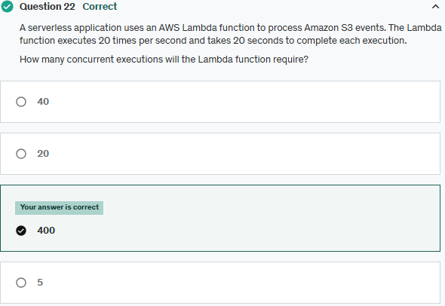

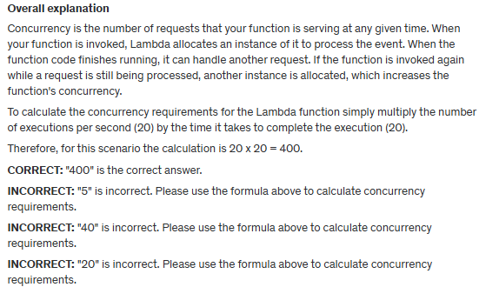

**References:**

<https://docs.aws.amazon.com/lambda/latest/dg/invocation-scaling.html>

**Save time with our AWS cheat sheets:**

<https://digitalcloud.training/aws-lambda/>

**Domain**

AWS Compute

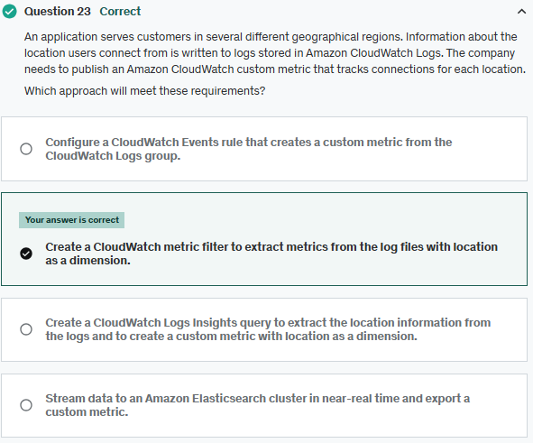

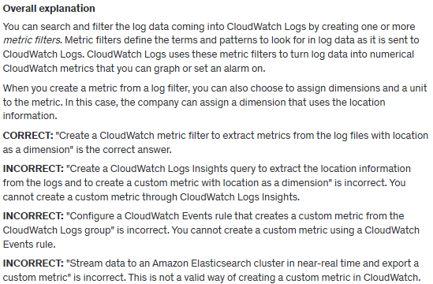

**References:**

<https://docs.aws.amazon.com/AmazonCloudWatch/latest/logs/MonitoringLogData.html>

**Save time with our AWS cheat sheets:**

<https://digitalcloud.training/amazon-cloudwatch/>

**Domain**

AWS Management & Governance

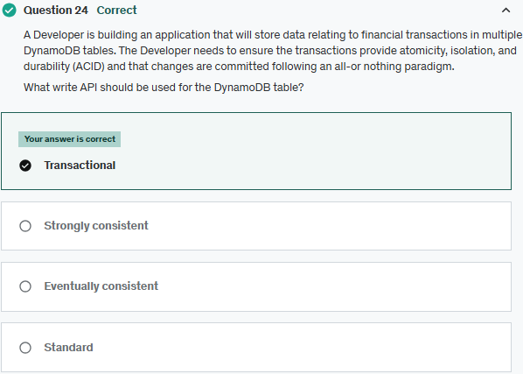

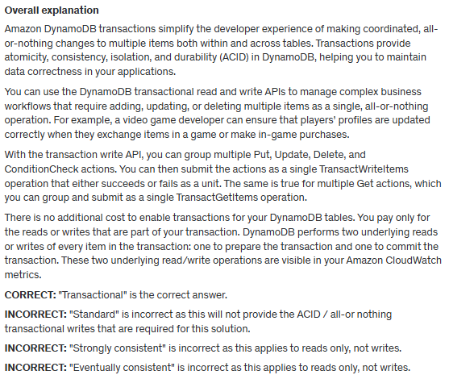

**References:**

<https://docs.aws.amazon.com/amazondynamodb/latest/developerguide/transactions.html>

**Save time with our AWS cheat sheets:**

<https://digitalcloud.training/amazon-dynamodb/>

**Domain**

AWS Database

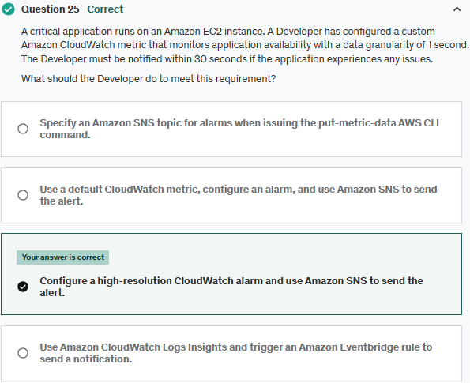

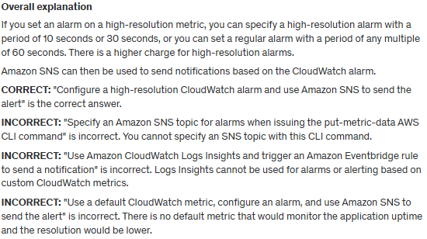

**References:**

<https://docs.aws.amazon.com/AmazonCloudWatch/latest/monitoring/AlarmThatSendsEmail.html#high-resolution-alarms>

**Save time with our AWS cheat sheets:**

<https://digitalcloud.training/amazon-cloudwatch/>

**Domain**

AWS Application Integration

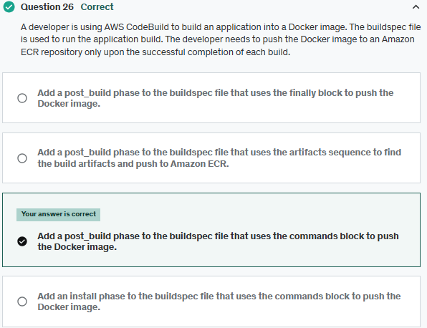

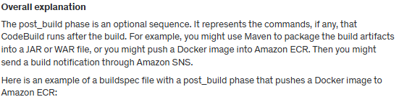

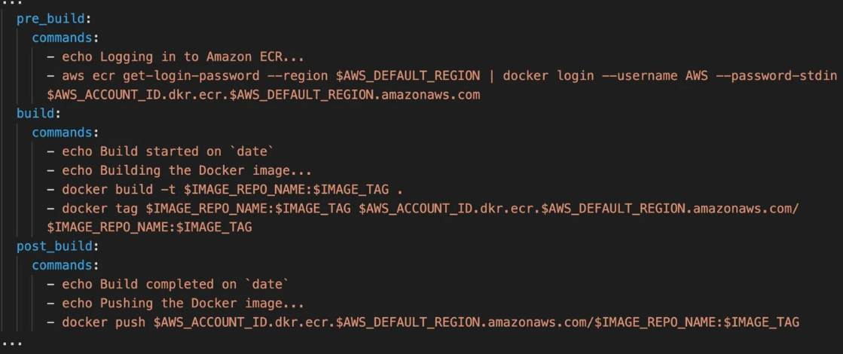

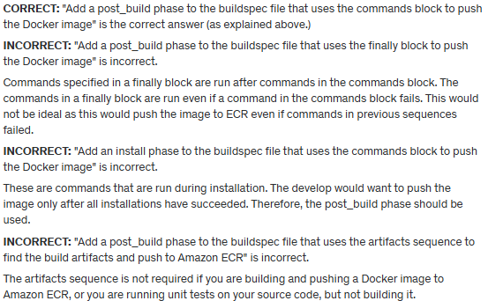

**References:**

<https://docs.aws.amazon.com/codebuild/latest/userguide/sample-docker.html>

<https://docs.aws.amazon.com/codebuild/latest/userguide/build-spec-ref.html>

**Save time with our AWS cheat sheets:**

<https://digitalcloud.training/aws-developer-tools/>

**Domain**

AWS Developer Tools

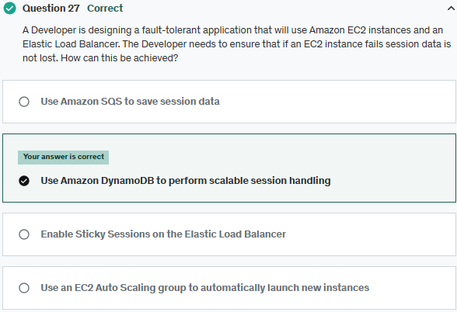

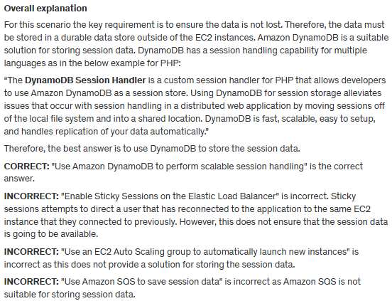

**References:**

<https://docs.aws.amazon.com/aws-sdk-php/v2/guide/feature-dynamodb-session-handler.html>

**Save time with our AWS cheat sheets:**

<https://digitalcloud.training/amazon-dynamodb/>

**Domain**

AWS Database

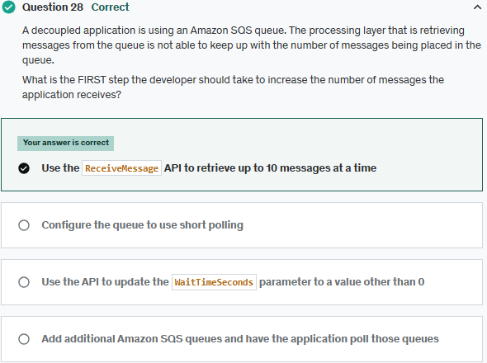

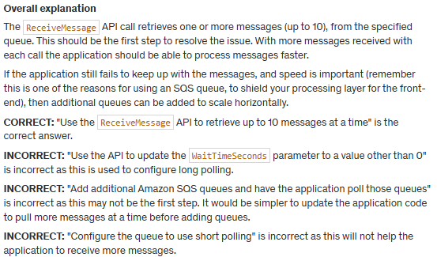

**References:**

<https://docs.aws.amazon.com/AWSSimpleQueueService/latest/APIReference/API_ReceiveMessage.html>

**Save time with our AWS cheat sheets:**

<https://digitalcloud.training/aws-application-integration-services/>

**Domain**

AWS Application Integration

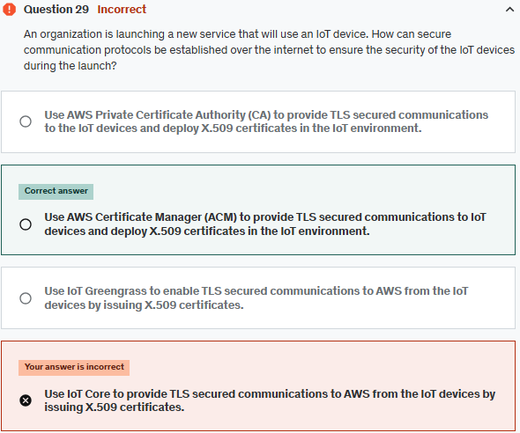

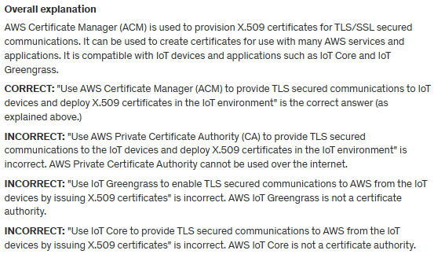

**References**:

<https://docs.aws.amazon.com/iot/latest/developerguide/device-certs-your-own.html>

**Domain**

AWS Security, Identity, & Compliance

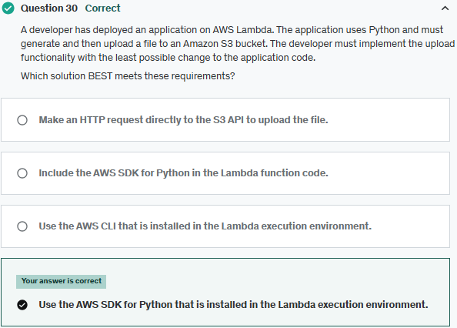

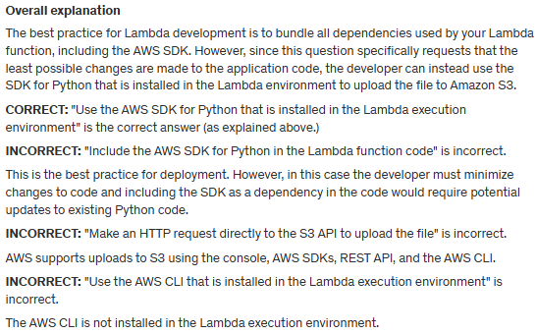

**References:**

<https://aws.amazon.com/blogs/compute/upcoming-changes-to-the-python-sdk-in-aws-lambda/>

**Save time with our AWS cheat sheets:**

<https://digitalcloud.training/aws-lambda/>

**Domain**

AWS Compute

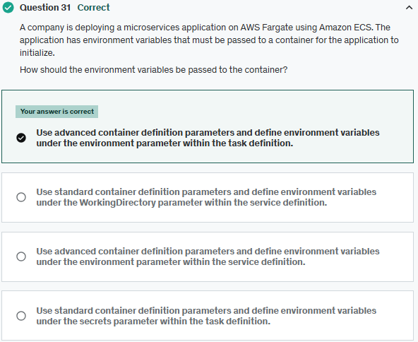

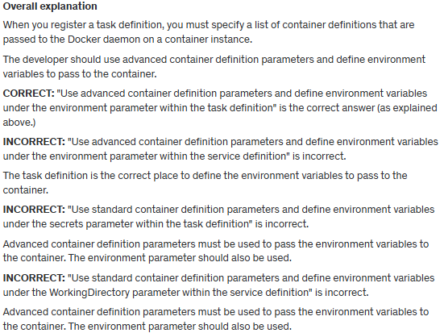

**References:**

<https://docs.aws.amazon.com/AmazonECS/latest/userguide/task_definition_parameters.html#container_definition_environment>

**Save time with our AWS cheat sheets:**

<https://digitalcloud.training/amazon-ecs-and-eks/>

**Domain**

AWS Compute

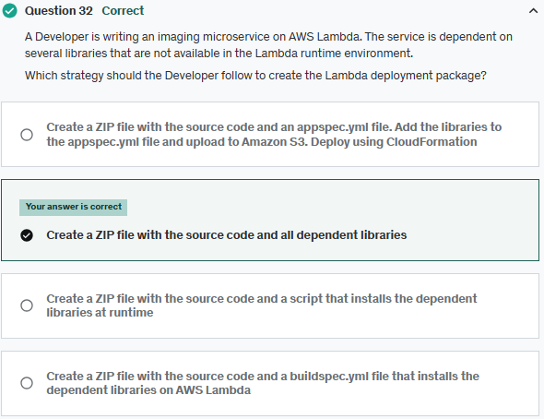

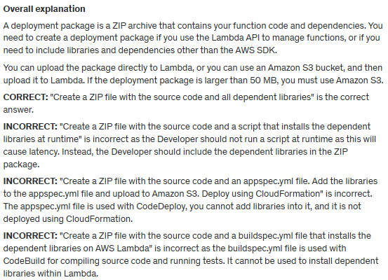

**References:**

<https://docs.aws.amazon.com/lambda/latest/dg/python-package.html>

**Save time with our AWS cheat sheets:**

<https://digitalcloud.training/aws-lambda/>

**Domain**

AWS Compute

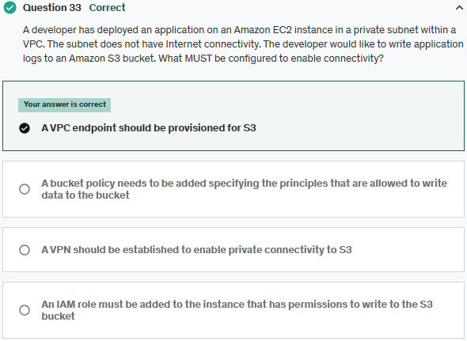

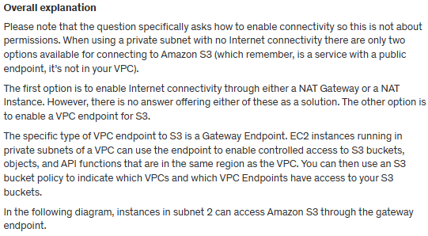

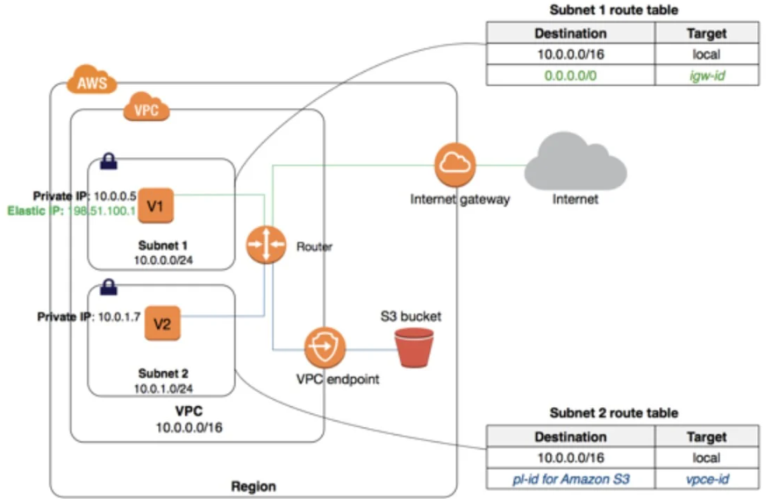

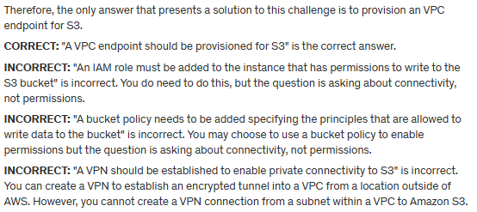

**References:**

<https://docs.aws.amazon.com/vpc/latest/userguide/vpc-endpoints-s3.html>

**Save time with our AWS cheat sheets:**

<https://digitalcloud.training/amazon-s3-and-glacier/>

**Domain**

AWS Networking & Content Delivery

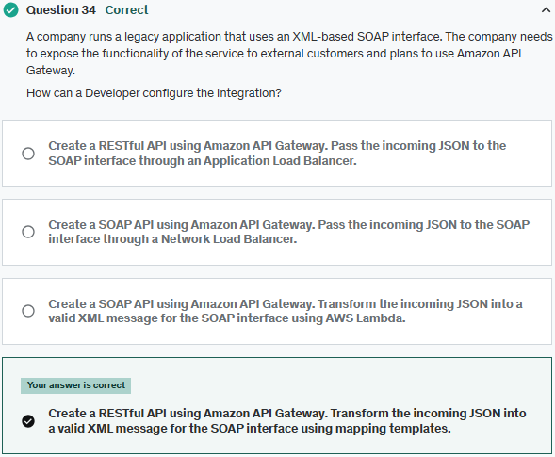

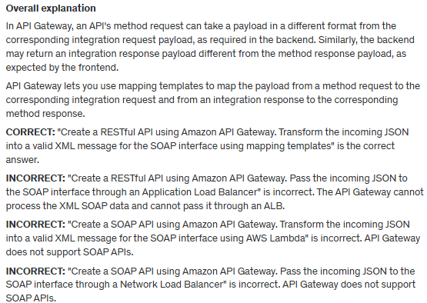

**References:**

[https://docs.aws.amazon.com/apigateway/latest/Developerguide/request-response-data-mappings.html](https://docs.aws.amazon.com/apigateway/latest/developerguide/request-response-data-mappings.html)

**Save time with our AWS cheat sheets:**

[https://digitalcloud.training/amazon-api-gateway/](https://digitalcloud.training/certification-training/aws-developer-associate/aws-networking-and-content-delivery/amazon-api-gateway/)

**Domain**

AWS Networking & Content Delivery

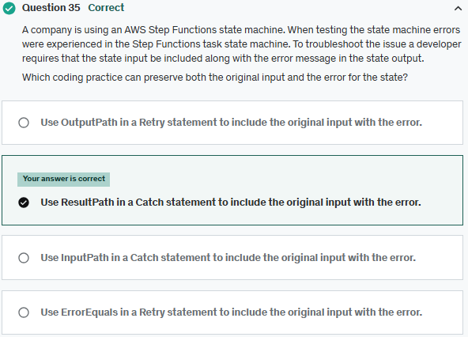

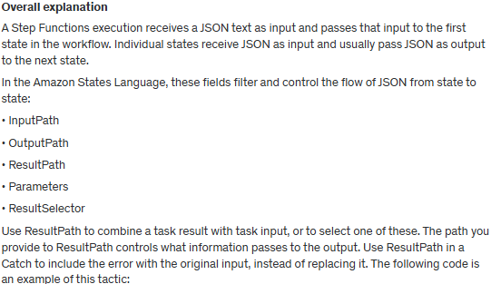

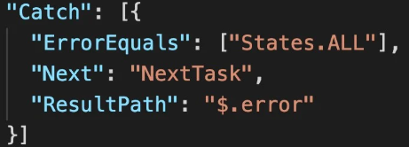

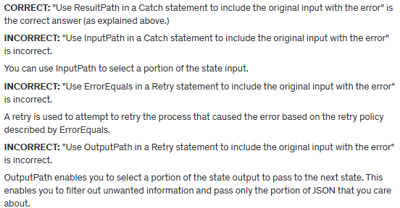

**References:**

<https://docs.aws.amazon.com/step-functions/latest/dg/input-output-resultpath.html>

<https://docs.aws.amazon.com/step-functions/latest/dg/tutorial-handling-error-conditions.html>

**Save time with our AWS cheat sheets:**

<https://digitalcloud.training/aws-application-integration-services/>

**Domain**

AWS Application Integration

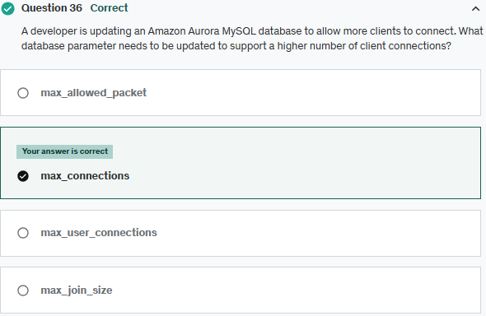

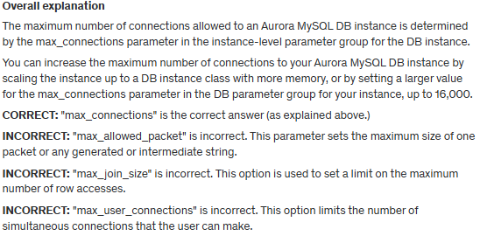

**References**:

<https://aws.amazon.com/premiumsupport/knowledge-center/rds-mysql-max-connections/>

**Save time with our AWS cheat sheets:**

<https://digitalcloud.training/amazon-aurora/>

**Domain**

AWS Database

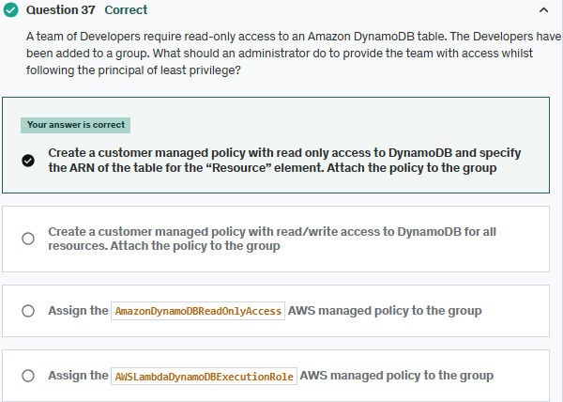

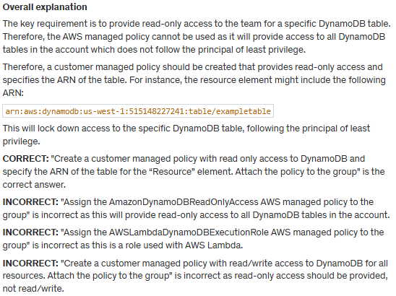

**References:**

<https://docs.aws.amazon.com/amazondynamodb/latest/developerguide/using-identity-based-policies.html>

**Save time with our AWS cheat sheets:**

<https://digitalcloud.training/amazon-dynamodb/>

**Domain**

AWS Database

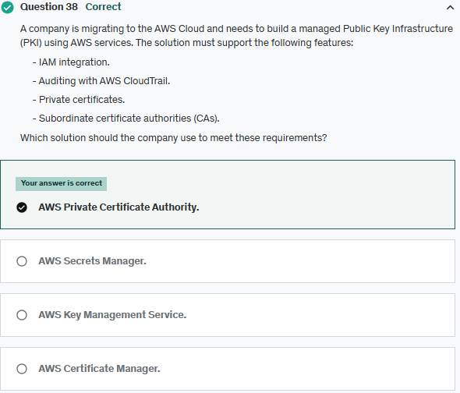

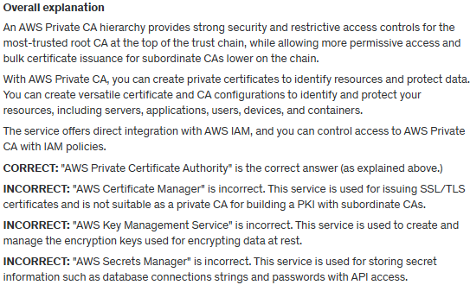

**References:**

<https://aws.amazon.com/private-ca/features/>

**Save time with our AWS cheat sheets:**

<https://digitalcloud.training/aws-certificate-manager/>

**Domain**

AWS Security, Identity, & Compliance

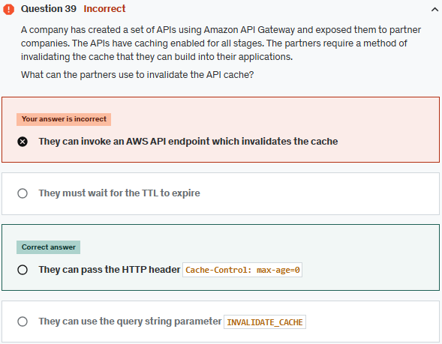

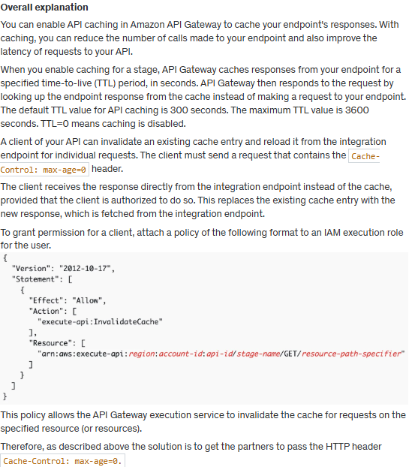

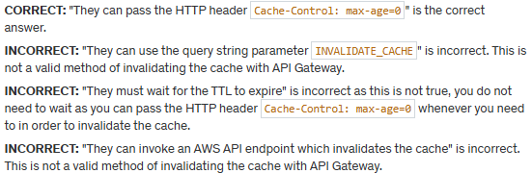

**References:**

<https://docs.aws.amazon.com/apigateway/latest/developerguide/api-gateway-caching.html>

**Save time with our AWS cheat sheets:**

<https://digitalcloud.training/amazon-api-gateway/>

**Domain**

AWS Networking & Content Delivery

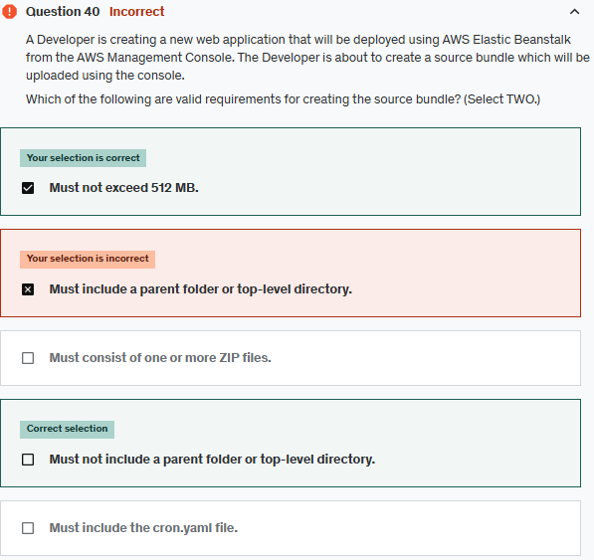

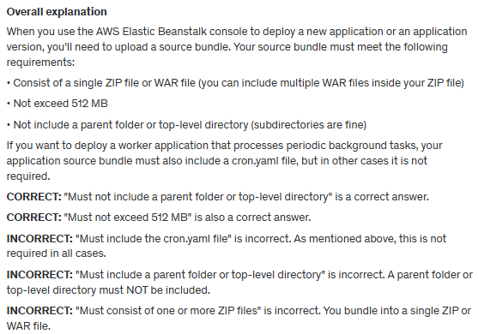

**References:**

<https://docs.aws.amazon.com/elasticbeanstalk/latest/dg/applications-sourcebundle.html>

**Save time with our AWS cheat sheets:**

<https://digitalcloud.training/aws-elastic-beanstalk/>

**Domain**

AWS Compute

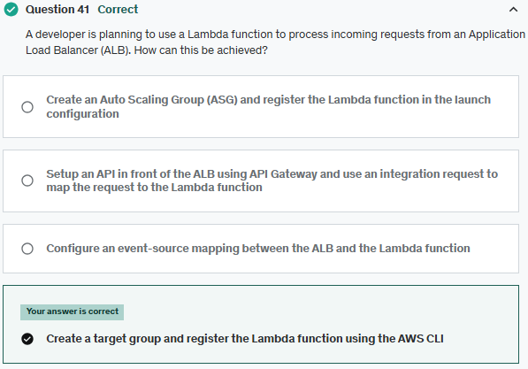

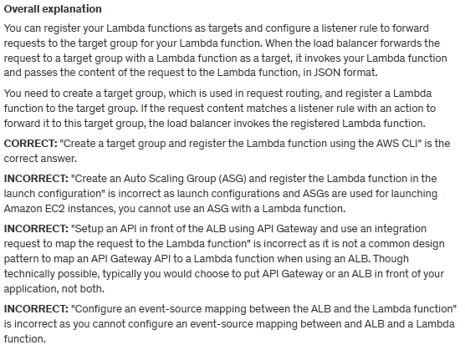

**References:**

<https://docs.aws.amazon.com/elasticloadbalancing/latest/application/lambda-functions.html>

**Save time with our AWS cheat sheets:**

<https://digitalcloud.training/aws-lambda/>

**Domain**

AWS Compute

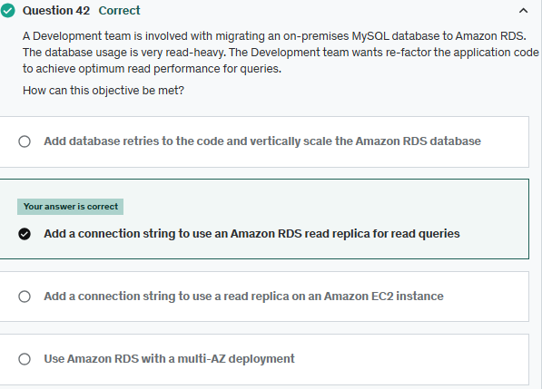

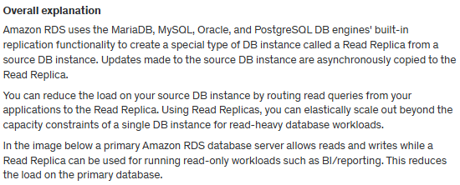

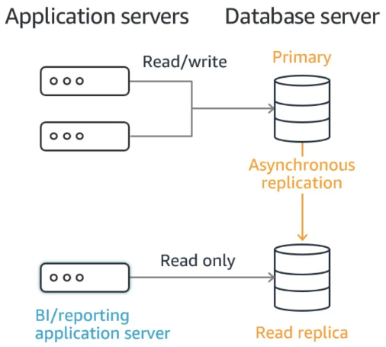

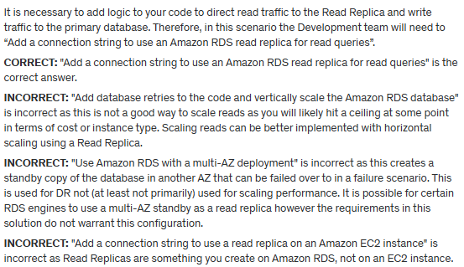

**References:**

<https://docs.aws.amazon.com/AmazonRDS/latest/UserGuide/USER_ReadRepl.html>

**Save time with our AWS cheat sheets:**

<https://digitalcloud.training/amazon-rds/>

**Domain**

AWS Database

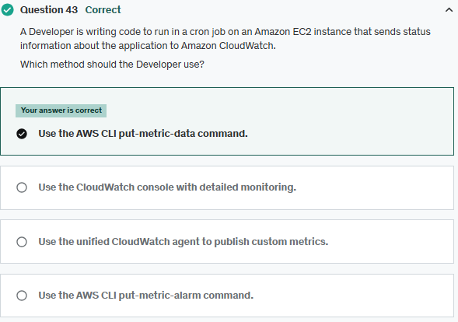

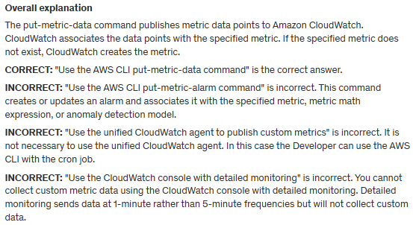

**References:**

<https://docs.aws.amazon.com/cli/latest/reference/cloudwatch/put-metric-data.html>

**Save time with our AWS cheat sheets:**

<https://digitalcloud.training/amazon-cloudwatch/>

**Domain**

AWS Management & Governance

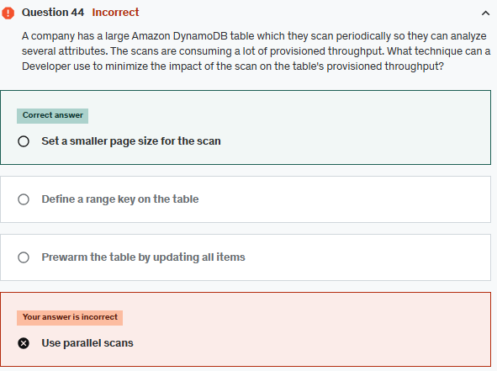

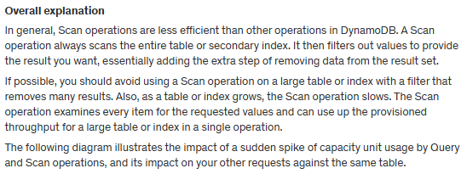

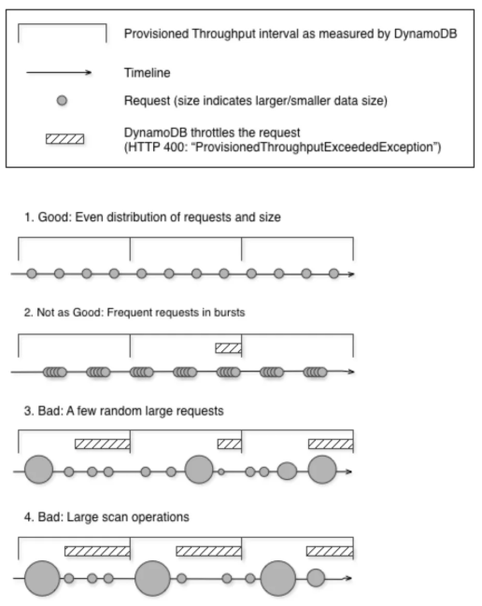

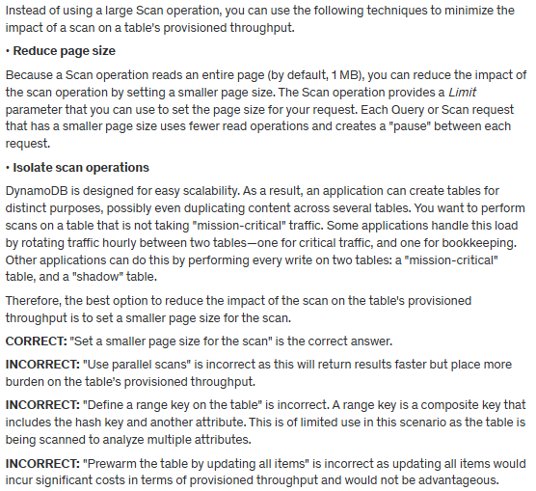

**References:**

<https://docs.aws.amazon.com/amazondynamodb/latest/developerguide/bp-query-scan.html>

**Save time with our AWS cheat sheets:**

<https://digitalcloud.training/amazon-dynamodb/>

**Domain**

AWS Database

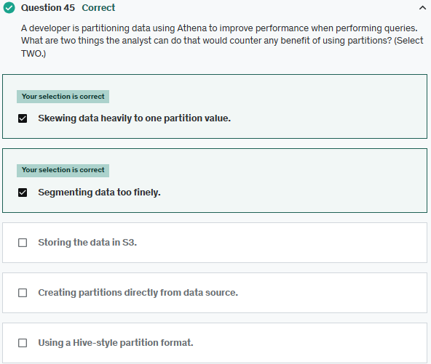

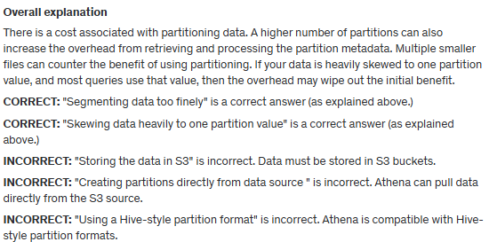

**References**:

<https://aws.amazon.com/blogs/big-data/top-10-performance-tuning-tips-for-amazon-athena/>

**Save time with our AWS cheat sheets:**

<https://digitalcloud.training/amazon-athena/>

**Domain**

AWS Analytics

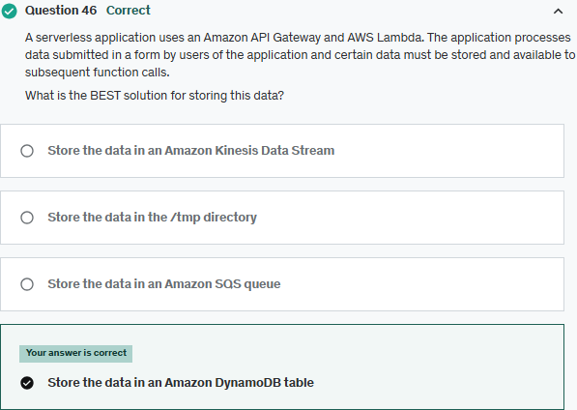

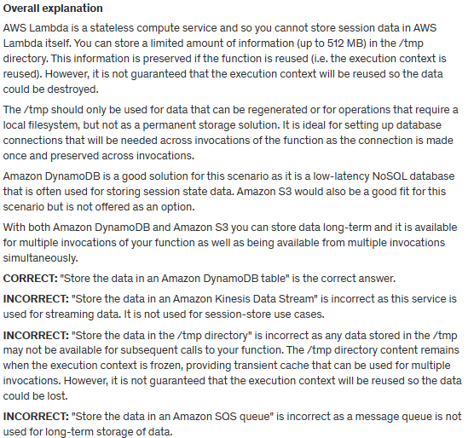

**References:**

<https://aws.amazon.com/dynamodb/>

**Save time with our AWS cheat sheets:**

<https://digitalcloud.training/amazon-dynamodb/>

**Domain**

AWS Database

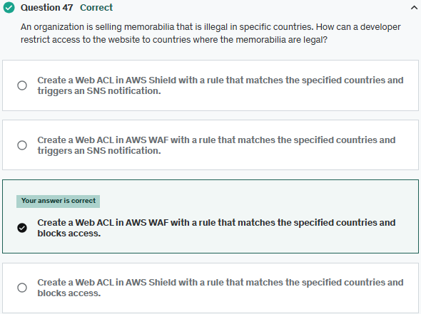

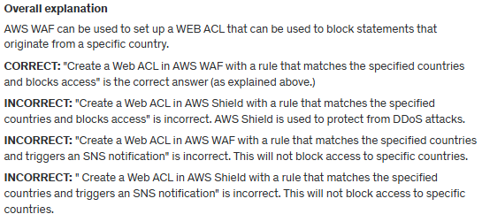

**References**:

<https://aws.amazon.com/premiumsupport/knowledge-center/waf-allow-block-country-geolocation/>

**Save time with our AWS cheat sheets:**

<https://digitalcloud.training/aws-waf-shield/>

**Domain**

AWS Security, Identity, & Compliance

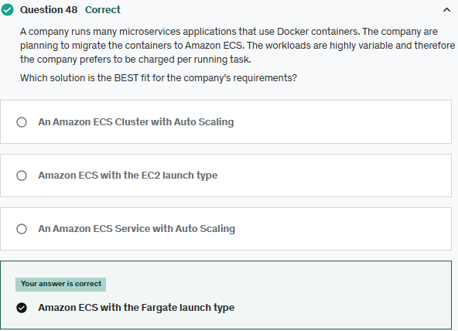

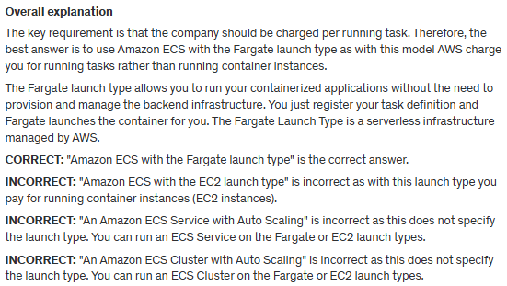

**References:**

<https://docs.aws.amazon.com/AmazonECS/latest/developerguide/AWS_Fargate.html>

**Save time with our AWS cheat sheets:**

<https://digitalcloud.training/amazon-ecs-and-eks/>

**Domain**

AWS Compute

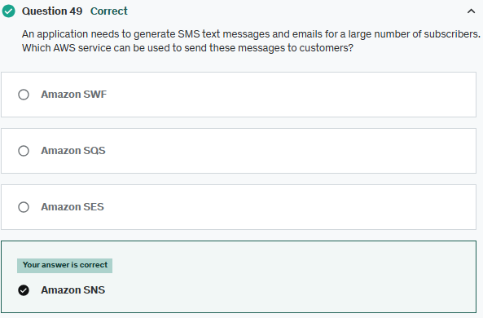

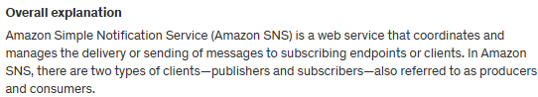

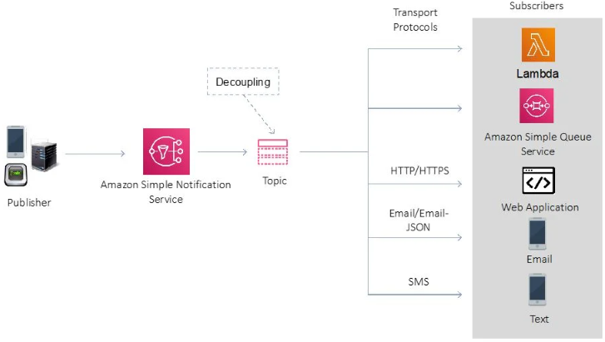

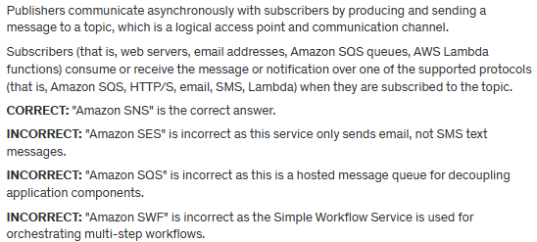

**References:**

<https://docs.aws.amazon.com/sns/latest/dg/welcome.html>

**Save time with our AWS cheat sheets:**

<https://digitalcloud.training/aws-application-integration-services/>

**Domain**

AWS Application Integration

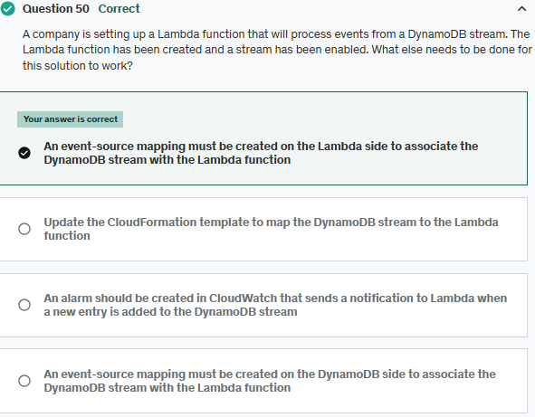

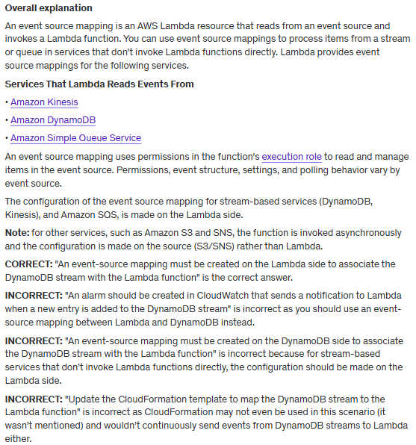

Amazon Kinesis <https://docs.aws.amazon.com/lambda/latest/dg/with-kinesis.html>

Amazon DynamoDB <https://docs.aws.amazon.com/lambda/latest/dg/with-ddb.html>

Amazon Simple Queue Service <https://docs.aws.amazon.com/lambda/latest/dg/with-sqs.html>

execution role <https://docs.aws.amazon.com/lambda/latest/dg/lambda-intro-execution-role.html>

**References:**

<https://docs.aws.amazon.com/lambda/latest/dg/invocation-eventsourcemapping.html>

**Save time with our AWS cheat sheets:**

<https://digitalcloud.training/aws-lambda/>

**Domain**

AWS Compute

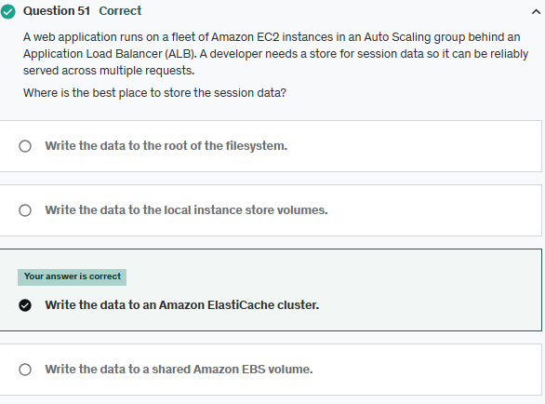

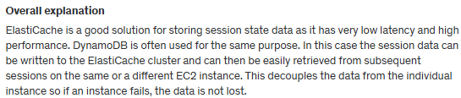

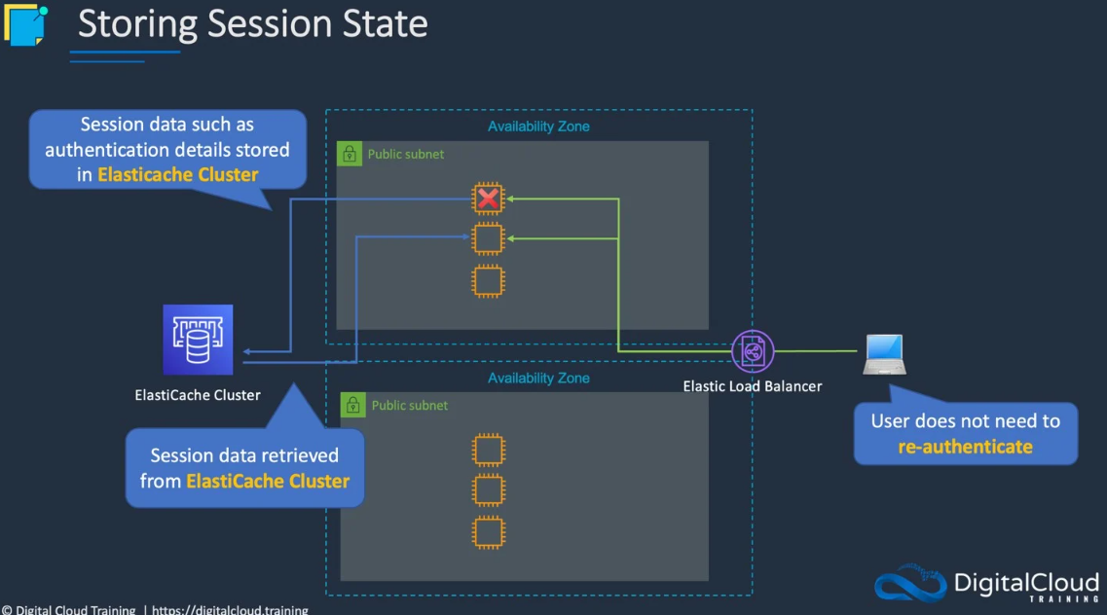

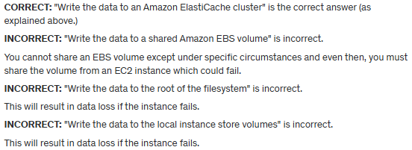

**References:**

<https://aws.amazon.com/caching/session-management/>

**Save time with our AWS cheat sheets:**

<https://digitalcloud.training/amazon-elasticache/>

**Domain**

AWS Database

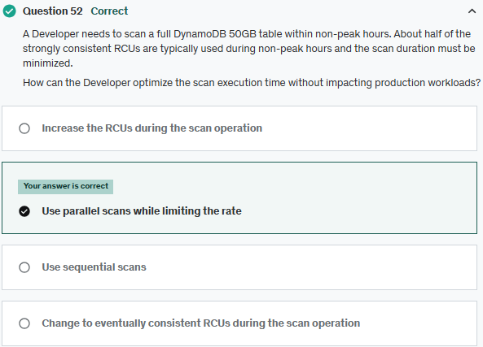

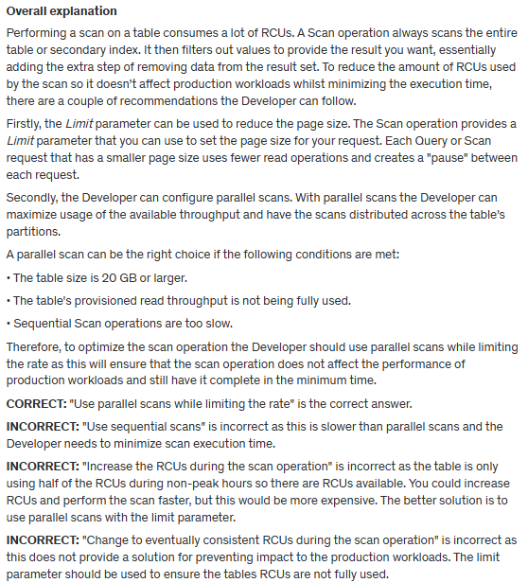

**References:**

<https://docs.aws.amazon.com/amazondynamodb/latest/developerguide/bp-query-scan.html#QueryAndScanGuidelines.ParallelScan>

**Save time with our AWS cheat sheets:**

[https://digitalcloud.training/amazon-dynamodb/](https://digitalcloud.training/certification-training/aws-developer-associate/aws-database/amazon-dynamodb/)

**Domain**

AWS Database

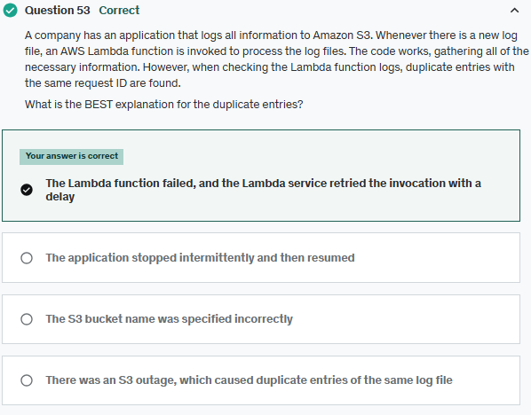

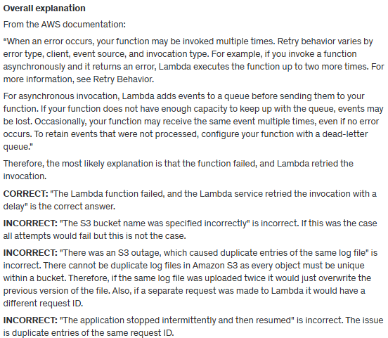

**References:**

<https://docs.aws.amazon.com/lambda/latest/dg/API_Invoke.html>

**Save time with our AWS cheat sheets:**

<https://digitalcloud.training/aws-lambda/>

**Domain**

AWS Compute

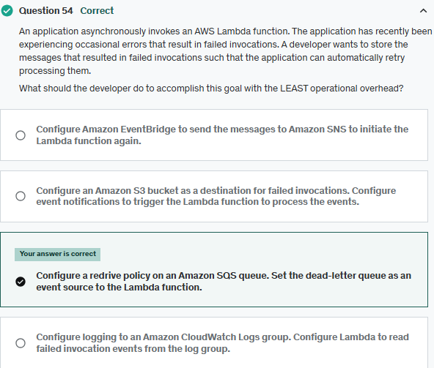

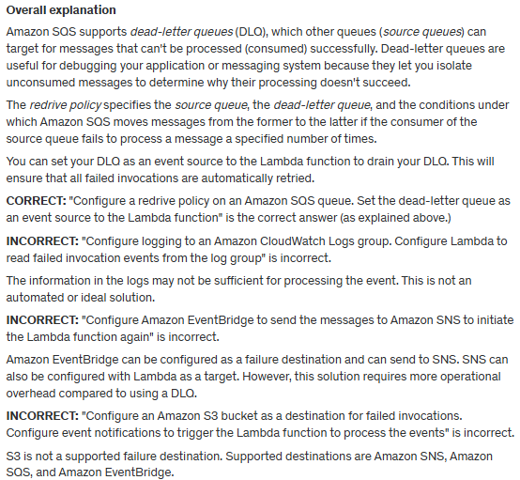

**References:**

<https://aws.amazon.com/blogs/compute/introducing-aws-lambda-destinations/>

<https://docs.aws.amazon.com/eventbridge/latest/userguide/eb-rule-dlq.html>

**Save time with our AWS cheat sheets:**

<https://digitalcloud.training/aws-application-integration-services/>

**Domain**

AWS Application Integration

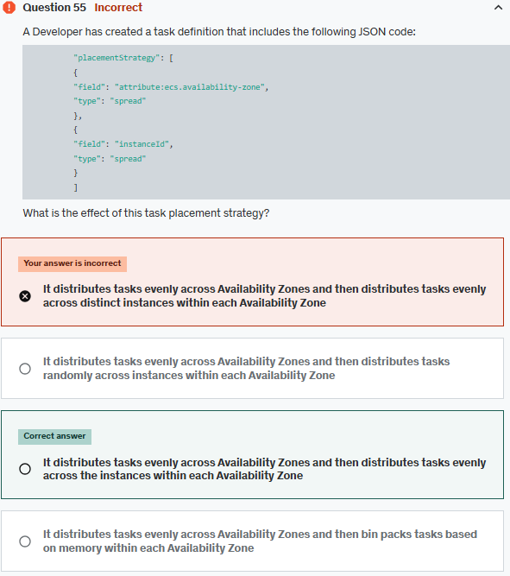

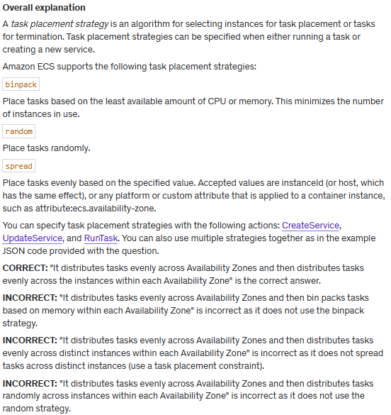

CreateService <https://docs.aws.amazon.com/AmazonECS/latest/APIReference/API_CreateService.html>

UpdateService <https://docs.aws.amazon.com/AmazonECS/latest/APIReference/API_UpdateService.html>

RunTask <https://docs.aws.amazon.com/AmazonECS/latest/APIReference/API_RunTask.html>

**References:**

<https://docs.aws.amazon.com/AmazonECS/latest/developerguide/task-placement-strategies.html>

**Save time with our AWS cheat sheets:**

<https://digitalcloud.training/amazon-ecs-and-eks/>

**Domain**

AWS Compute

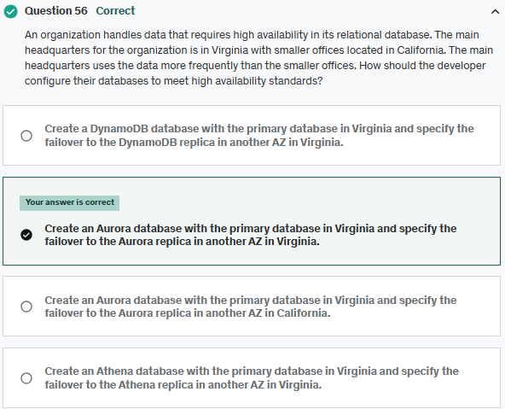

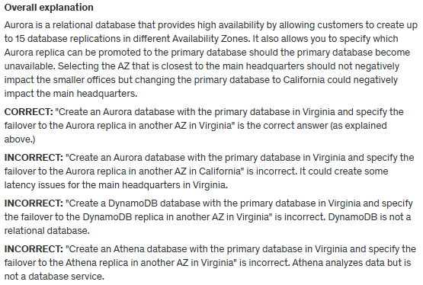

**References**:

<https://docs.aws.amazon.com/AmazonRDS/latest/AuroraUserGuide/Aurora.Overview.html>

**Save time with our AWS cheat sheets:**

<https://digitalcloud.training/amazon-aurora/>

**Domain**

AWS Database

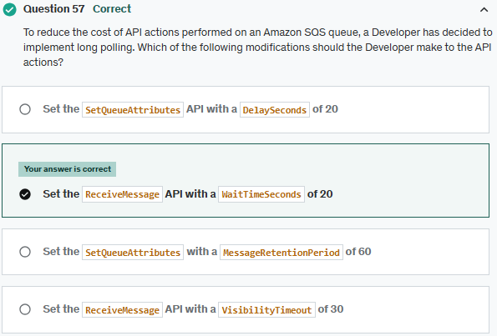

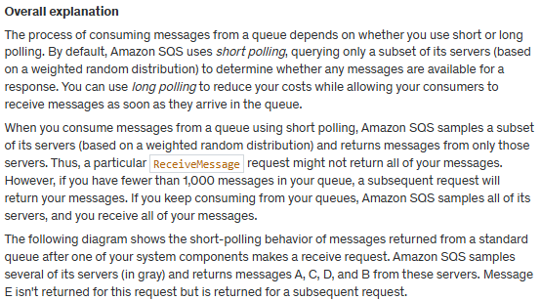

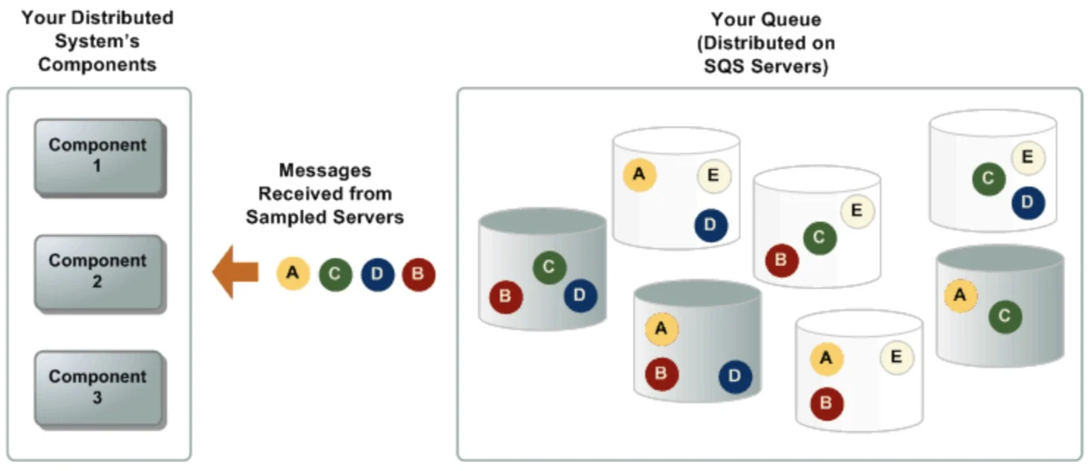

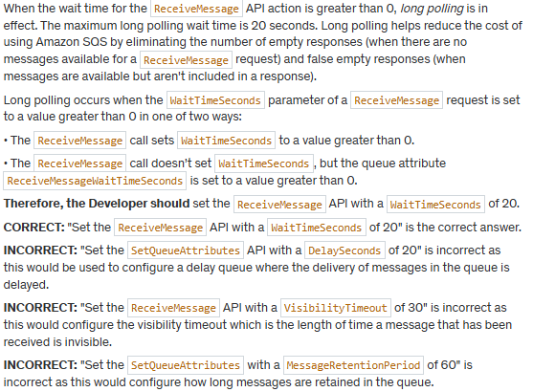

**References:**

<https://docs.aws.amazon.com/AWSSimpleQueueService/latest/SQSDeveloperGuide/sqs-short-and-long-polling.html>

<https://docs.aws.amazon.com/AWSSimpleQueueService/latest/APIReference/API_SetQueueAttributes.html>

<https://docs.aws.amazon.com/AWSSimpleQueueService/latest/APIReference/API_ReceiveMessage.html>

**Save time with our AWS cheat sheets:**

<https://digitalcloud.training/aws-application-integration-services/>

**Domain**

AWS Application Integration

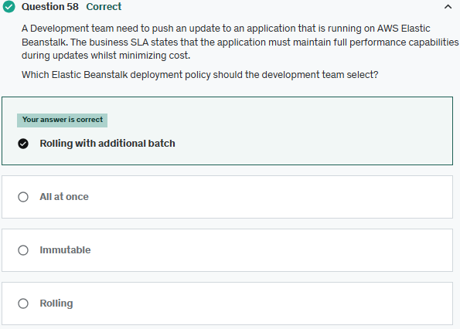

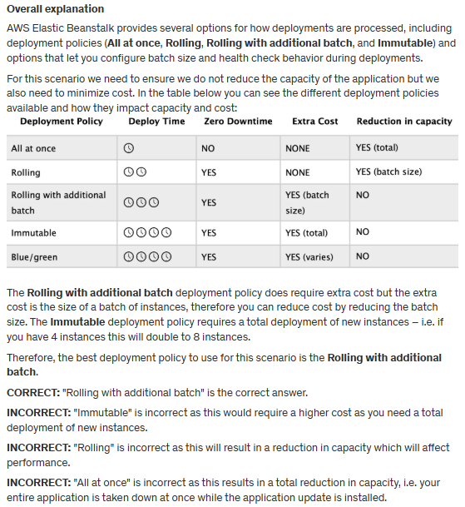

**References:**

<https://docs.aws.amazon.com/elasticbeanstalk/latest/dg/using-features.rolling-version-deploy.html>

**Save time with our AWS cheat sheets:**

<https://digitalcloud.training/aws-elastic-beanstalk/>

**Domain**

AWS Compute

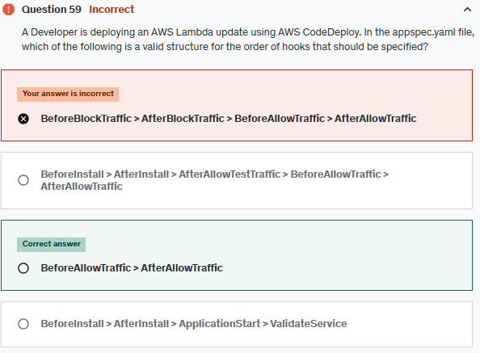

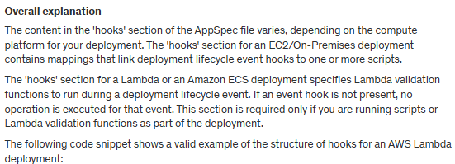

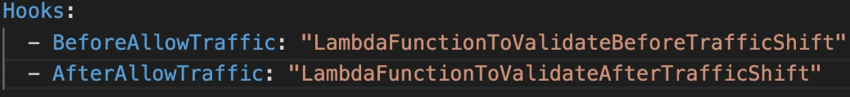

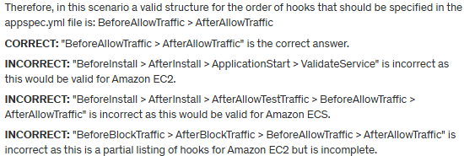

**References:**

<https://docs.aws.amazon.com/codedeploy/latest/userguide/reference-appspec-file-structure-hooks.html>

**Save time with our AWS cheat sheets:**

<https://digitalcloud.training/aws-developer-tools/>

**Domain**

AWS Compute

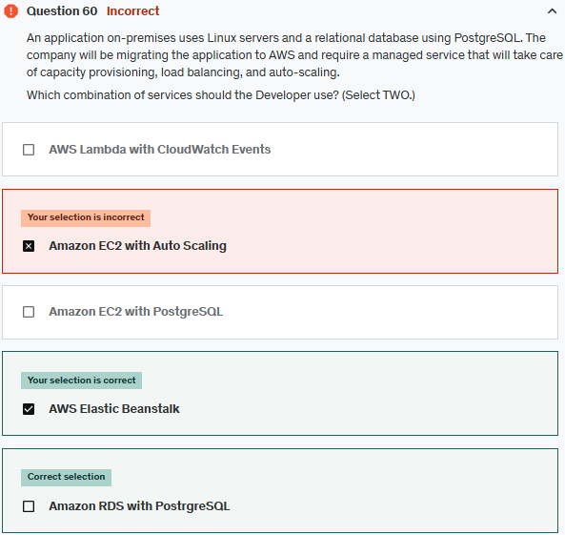

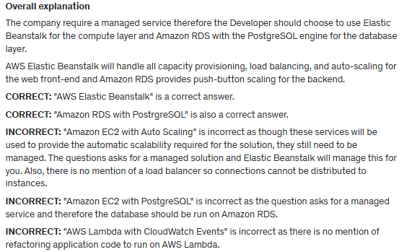

**References:**

<https://aws.amazon.com/elasticbeanstalk/>

<https://aws.amazon.com/rds/postgresql/>

**Save time with our AWS cheat sheets:**

<https://digitalcloud.training/aws-elastic-beanstalk/>

<https://digitalcloud.training/amazon-rds/>

**Domain**

AWS Compute

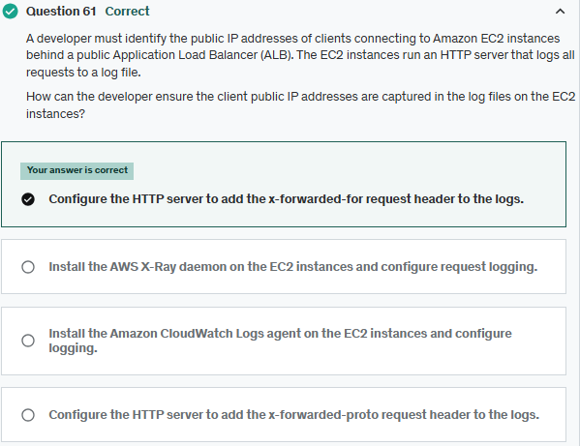

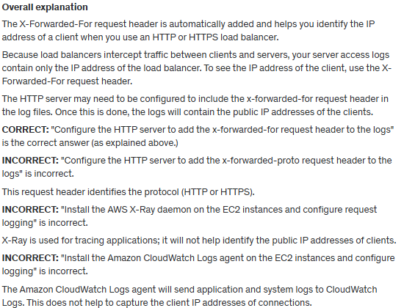

**References:**

<https://docs.aws.amazon.com/elasticloadbalancing/latest/application/x-forwarded-headers.html#x-forwarded-for>

**Save time with our AWS cheat sheets:**

<https://digitalcloud.training/aws-elastic-load-balancing-aws-elb/>

**Domain**

AWS Compute

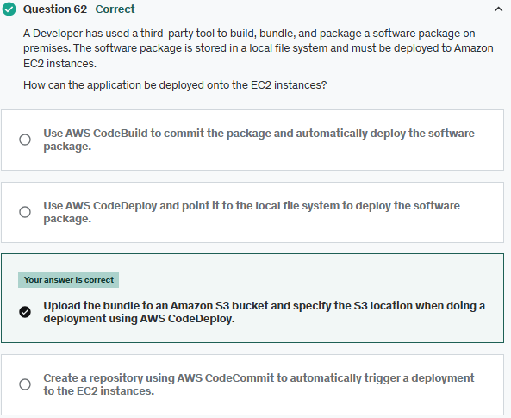

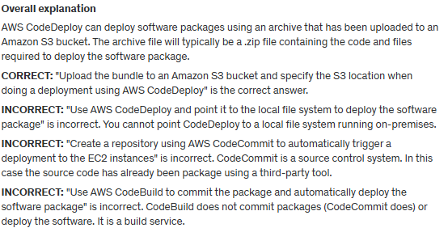

**References:**

<https://docs.aws.amazon.com/codedeploy/latest/userguide/tutorials-windows-upload-application.html>

**Save time with our AWS cheat sheets:**

<https://digitalcloud.training/amazon-s3-and-glacier/>

**Domain**

AWS Developer Tools

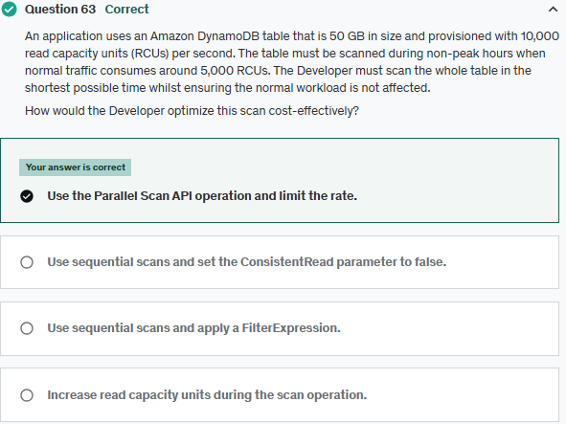

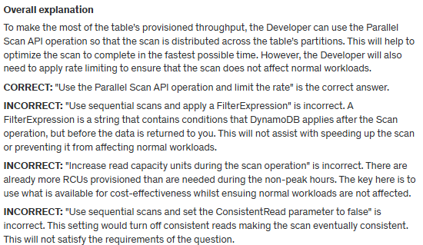

**References:**

[https://aws.amazon.com/blogs/Developer/rate-limited-scans-in-amazon-dynamodb/](https://aws.amazon.com/blogs/developer/rate-limited-scans-in-amazon-dynamodb/)

**Save time with our AWS cheat sheets:**

<https://digitalcloud.training/amazon-dynamodb/>

**Domain**

AWS Database

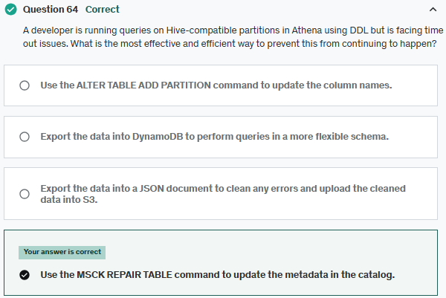

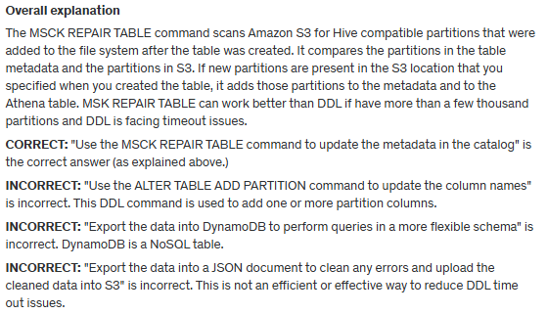

**References**:

<https://docs.aws.amazon.com/athena/latest/ug/msck-repair-table.html>

**Save time with our AWS cheat sheets:**

<https://digitalcloud.training/amazon-athena/>

**Domain**

AWS Analytics

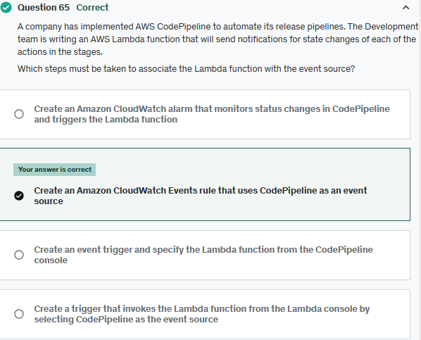

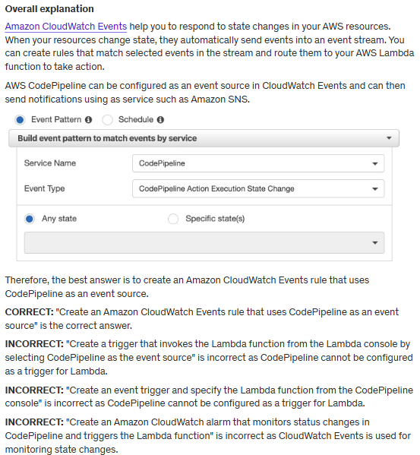

Amazon CloudWatch Events help <https://docs.aws.amazon.com/eventbridge/latest/userguide/eb-cwe-now-eb.html>

**References:**

<https://docs.aws.amazon.com/AmazonCloudWatch/latest/events/WhatIsCloudWatchEvents.html>

**Save time with our AWS cheat sheets:**

<https://digitalcloud.training/amazon-cloudwatch/>

**Domain**

AWS Management & Governance